Before watching 00:00-00:20
Exercise 1 Read the four descriptions on page two and watch the intro to the film. Find the names of the characters and learn to describe their personal appearance.
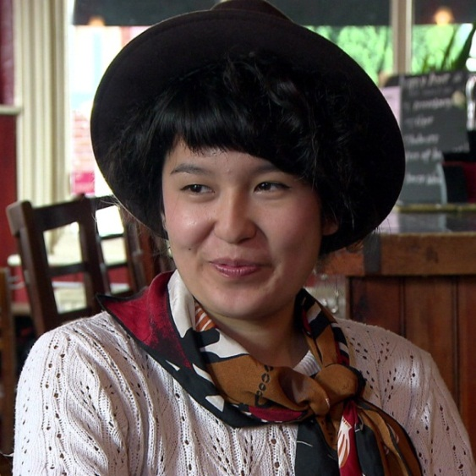 |  |  | 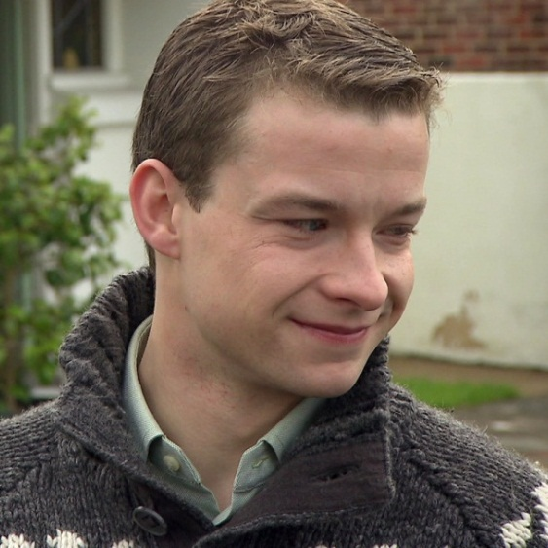

Gender male Age early to mid-20s

Appearance mediterranean type, mixed ethnical background with one German parent and one parent from
the Balkans; short to medium height, black hair, dark eyes, very handsome, very fit and sporty

Traits stubborn, extroverted, strong-willed, creative, skilled in many different areas, has the reputation of a player but but doesn‘t act on it very often; has a good heart but acts rather irrationally, streetsmart

Part in “Flirt English“ He is Hannes‘ best friend but does not study at a University. He has not found the right job yet so he works part-time in different areas. He is very interested in all kinds of sports, having worked as an amateur coach for a children‘s football team. His strong will and impulsiveness might get him into trouble from now and then; he does not shy
away from an argument.
Gender male Age early 20s

Appearance white, German; slender, tall; short dark hair; brown or green eyes; dresses rather conservatively for a University student

Traits friendly, polite, sensitive, rational, not too extroverted, very methodical, organized, intelligent

Part in “Flirt English“ He is an informatics student with a strong interest in computers and science. Occasionally, he acts like a bit of a nerd. He is single, not exactly shy but also not quick to act in romantic affairs. His best friend Nino is a lot more extroverted than him but Hannes is also the one to hold Nino back before he gets into trouble. Because Hannes thinks before he acts, he‘s very good at considering other people‘s feelings.
Gender female Age mid 20s

Appearance of mixed ethnicity with a Bolivian mother and a Chinese father; slender, short; long black hair with a lot of different hairstyles; dark eyes; dresses very fashionably in self-made vintage clothes

Traits very strong-willed and outspoken; with strong opinions; likes to organize and strategize; slightly bossy; very interested in arts, music and culture; very creative, good at reading people

Part in “Flirt English“ Because she is strong-willed and does not shy away from conflict, she sometimes gets into arguments. She is also the slightly pessimistic one who has to be convinced of new ideas; once she comes around, however, there‘s no stopping her. It is not clear if she is single or whether she is interested in a relationship.
Gender female Age early 20s

Appearance white, English; slender, medium height, very sporty; pretty face; medium to long curly brown hair; brown, blue or green eyes; dresses well but not too sexy

Traits smart, flirtatious, always gets what she wants; adventurous, outgoing, fun-loving

Part in “Flirt English“ She is “the pretty one“ and knows it: A lot of boys have fallen for her and she takes her time picking the right one. She would never steal another girl‘s boyfriend, however. Her most important hobby is karate which she is very good at; this shows that she has discipline and a strong will. She loves the outdoors and leads a very active life.

