While watching 00:22-05:50
Exercise 1: Watch the first two scenes and bring the pictures into the right order.
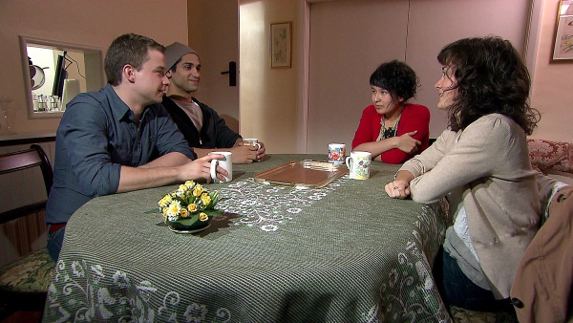 |  | 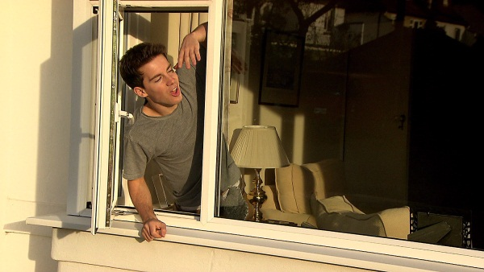
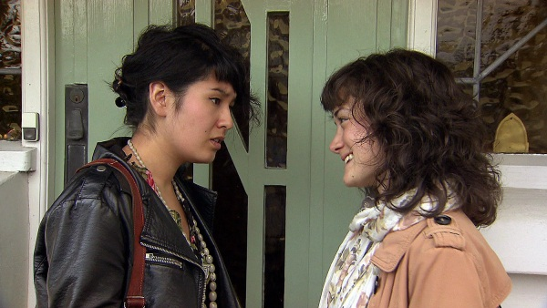
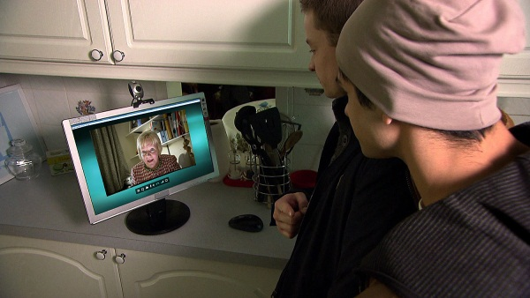
While watching 00:22-05:50
Exercise 2: Watch the same scenes again and check your answers.

Exercise 3: Match each picture with the appropriate sentences from the list on the next page. Attention: Some pictures have more than one matching sentence and not every sentence matches with a picture.
Exercise 4: Are you up for a bigger challenge? Are you confident enough? Write your own summary for each picture.

1.
2.
3.
4.
5.
6.
7.
8.

Sentences to match the pictures

When the girls arrive at the house, they ask for a word in private.
Their neighbour Phil finally tells them that the landlady is in Ireland.
There‘s a note from Lily in the envelope, but it‘s addressed to Elizabeth and Holly.
A ringing noise from a computer alerts them to a webcam call from Lily.
They try to call their landlady but she does not answer the phone.
The first thing they do once inside the house is to use the bathroom and switch on the television.
As they introduce themselves to each other, Lily gets Hannes name wrong and immediately apologizes.
Lily informs the boys that the girls will arrive at six o‘clock.
Phil hands them an envelope with the keys to Lily’s house.
Meanwhile, Nino and Hannes decide to make dinner for the girls to win them over.
Elisabeth tells Holly that she doesn‘t like the two guys in the house. Holly convinces Elizabeth to give it a try.
Nino and Hannes arrive at No. 2 Silverleaf Gardens but nobody opens the door.

After the boys have served tea, the four of them talk a little bit.

While watching 05:50-09:53
Exercise 5: Watch the rest of the movie and decide if the sentences are correct or false.

t | f
 |  | The girls say that they are willing to share the house with the boys.
 |  | Hannes explains that he will be doing an eight month course on how to build a flying speedboat.
 |  | Nino suggests that the boys can sleep in a tent in the garden.
 |  | Holly is doing a course on teaching English as a foreign language.
 |  | Nino says he‘s looking for a job.
 |  | Nino sets out to finish cooking the fish.
 |  | Elizabeth wants to become a doctor.
 |  | As they are talking, an e-mail from Lily arrives.
 |  | She has left shepherd‘s pie for her lodgers to eat.
 |  | Nino has come to Brighton to visit his relatives.
Exercise 5: You now know which sentences are incorrect. Write them correctly.
_____________________________________________________________________________________________________________________________________________________________________________________________________________________________________________________________________________________________________________________________________________________________________________________________________________________________________________________________________________________________________________________________________________________________________________________________________________________________________________________________________________________________________________________________________________________________________________________________________________________________________________________________________________________________________________________________________________________________________________________________________________________________________________________________________________________________

