Interessensgruppe | Nutzungsansprüche an die Nationalparkregion
Fischerei  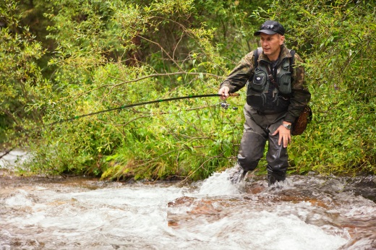 | __________________________________________________________________________________________________________________________________________________________________________________________________________________________________________________________________________________________________________________________________________________________________________________________________________________________________________________________________
Stromwirtschaft  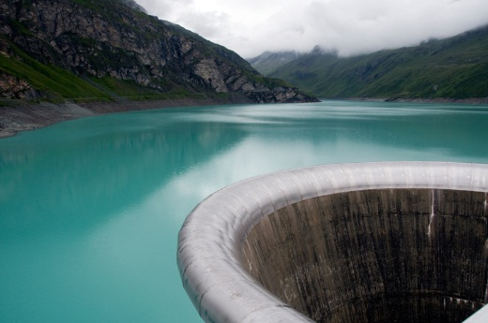 | __________________________________________________________________________________________________________________________________________________________________________________________________________________________________________________________________________________________________________________________________________________________________________________________________________________________________________________________________
Landwirtschaft  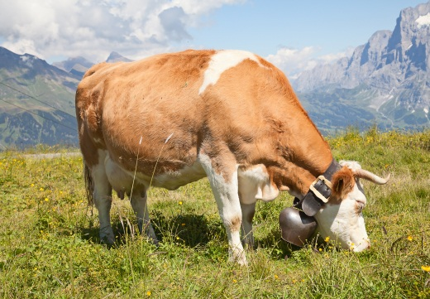 | __________________________________________________________________________________________________________________________________________________________________________________________________________________________________________________________________________________________________________________________________________________________________________________________________________________________________________________________________
Naturschutz  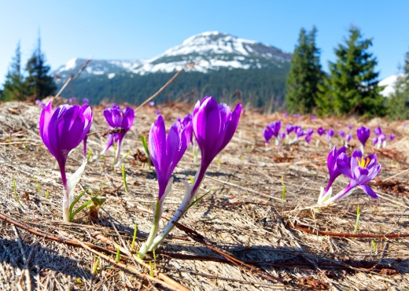 | __________________________________________________________________________________________________________________________________________________________________________________________________________________________________________________________________________________________________________________________________________________________________________________________________________________________________________________________________
Tourismus  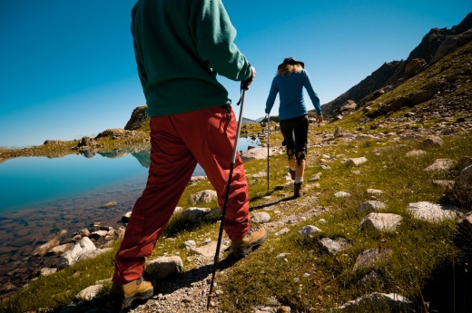 | __________________________________________________________________________________________________________________________________________________________________________________________________________________________________________________________________________________________________________________________________________________________________________________________________________________________________________________________________
Jagd  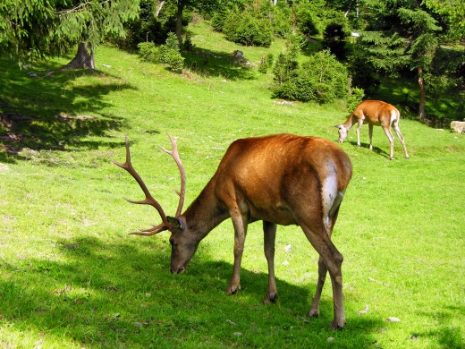 | __________________________________________________________________________________________________________________________________________________________________________________________________________________________________________________________________________________________________________________________________________________________________________________________________________________________________________________________________
Forstwirtschaft  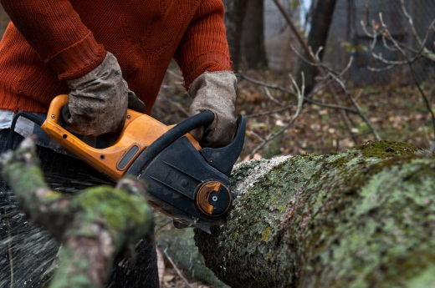 | __________________________________________________________________________________________________________________________________________________________________________________________________________________________________________________________________________________________________________________________________________________________________________________________________________________________________________________________________
Bauwirtschaft | __________________________________________________________________________________________________________________________________________________________________________________________________________________________________________________________________________________________________________________________________________________________________________________________________________________________________________________________________

