Aufgabe 1
Soll Beni das frische Brot essen? Welche Gründe dafür und dagegen werden im Film genannt? Was wird zu diesen Gründen gesagt?
Gründe dafür | ______________________________________________________________________________________________________________________________________________________________________________________________________________________________________________________________________________________________________________________________________________________
Bewertung der Gründe  Bemerkungen | _______________________________________________________________________________________________________________________________________________________________________________________________________________________________________________________________________________________________________________________________________________________________________________________________________________

Gründe dagegen | ______________________________________________________________________________________________________________________________________________________________________________________________________________________________________________________________________________________________________________________________________________________
Bewertung der Gründe  Bemerkungen | _______________________________________________________________________________________________________________________________________________________________________________________________________________________________________________________________________________________________________________________________________________________________________________________________________________
Alle Bilder: Wikimedia Commons

Aufgabe 2
Was ist «Food Waste»?

____________________________________________________________________________________________________________________________________________________________________________________________________________________________________________________________________________________________________________________________________________________________________________________________________________________________________________________________________________________________________________

Wo entsteht «Food Waste»?

______________________________________________________________________________________________________________________________________________________________________________________________________________________________________________________________________________________________________________________________________________________________________________________________________________________________________________________________________________________________________________________________________________________________________________________________

Wie kann man als Einzelner im Haushalt weniger Lebensmittel verschwenden?

________________________________________________________________________________________________________________________________________________________________________________________________________________________________________________________________________________________________________________________________________________________________________________________________________________________________________________________________________________________________________________________________________________________________________________________________________________________________________________________________________________
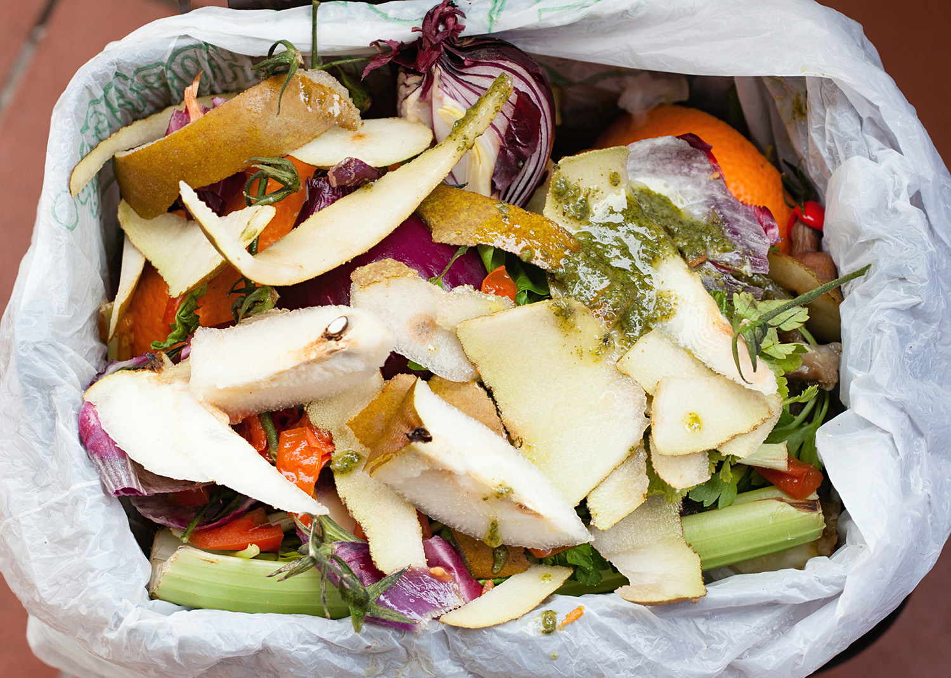
Bild: Colourbox

