Fragen zur Filmsequenz 10:00 - 12:16 | 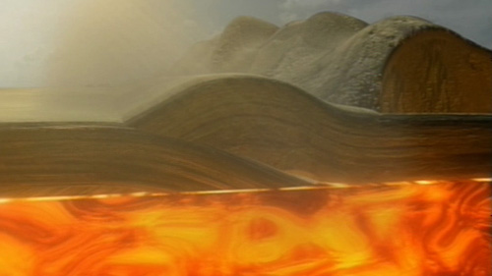 Abbildung 1  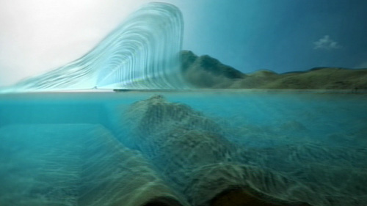 Abbildung 2  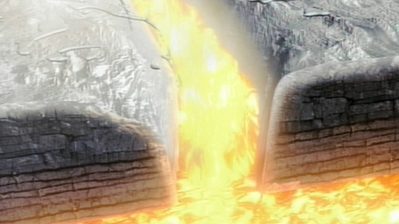 Abbildung 3
1. Auf welche drei Arten können Erdbeben entstehen? (Abbildungen 1 - 3)
____________________________________________________________________________________
____________________________________________________________________________________
____________________________________________________________________________________
____________________________________________________________________________________
____________________________________________________________________________________
____________________________________________________________________________________
____________________________________________________________________________________
____________________________________________________________________________________
____________________________________________________________________________________
2. Was ist an Island tektonisch gesehen besonders?
____________________________________________________________________________________
____________________________________________________________________________________
____________________________________________________________________________________
____________________________________________________________________________________
____________________________________________________________________________________

