1. Begriffsdefinition:
Verwerfung:
____________________________________________________________________________________________________________________________________________________________________________________________________________________________________________________________________________________________________________________________________
Transformstörungen:
___________________________________________________________________________________________________________________________________________________________________________________________________________________________________________________________________________________________________________________________________
Magnitudenskala/Seismogramm:
____________________________________________________________________________________________________________________________________________________________________________________________________________________________________________________________________________________________________________________________________
Epizentrum/Hypozentrum:
____________________________________________________________________________________________________________________________________________________________________________________________________________________________________________________________________________________________________________________________________
2. Warum ist Los Angeles besonders erdbebengefährdet?
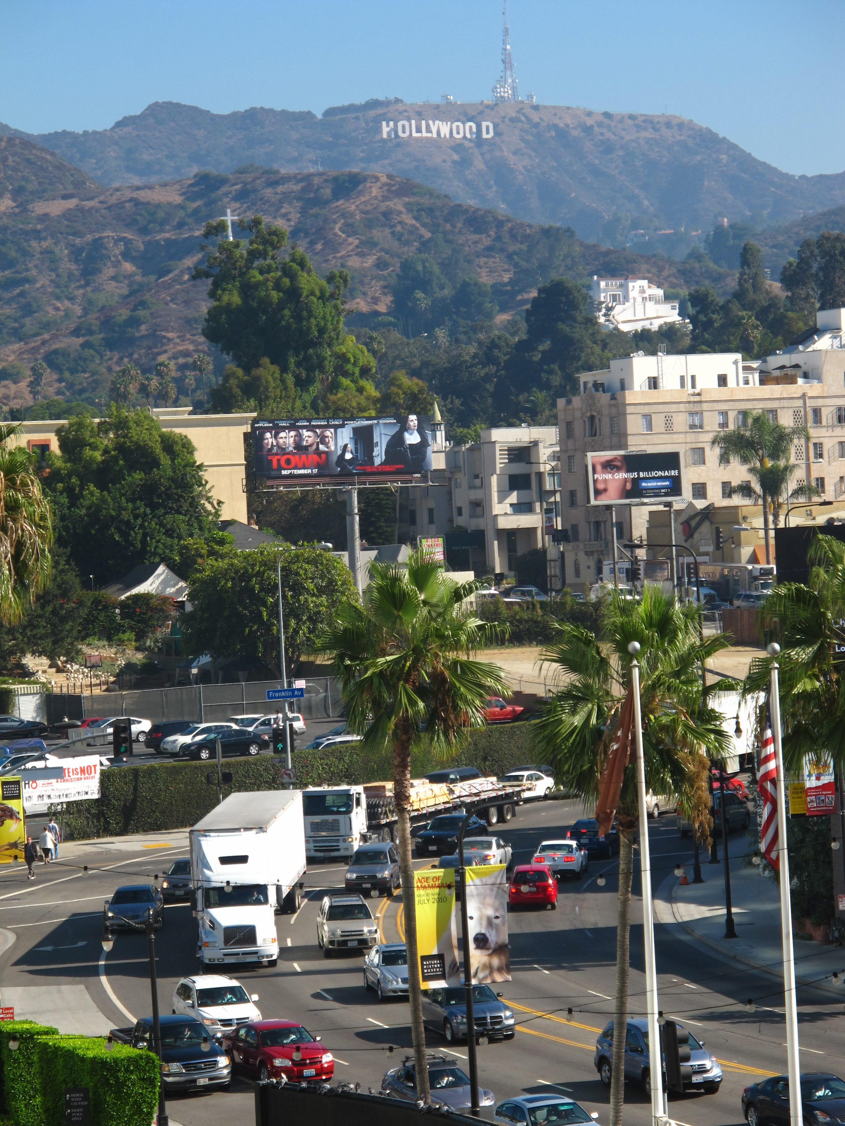
___________________________________________________________________________________________________________________________________________________________________________________________________________________________________________________________________________________________________________________________________________________________________________________________________________________________________________________________________________________________________________________________________________________________________________________________________________________________________________________ Bild: Colourbox

