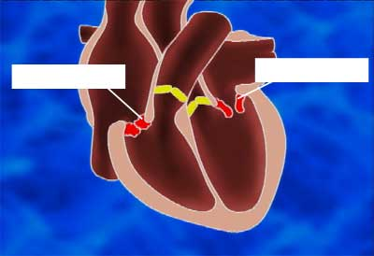  Untight valves  Calcified valves |  |  | Problem number 1:  The valves can become calcified. The blood accumulates, the pressure increases.  Or the valves don’t shut tightly any more, so that some of the blood flows back.
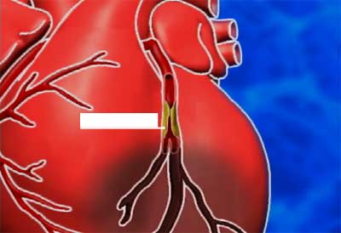  Narrowing |  |  | Problem number 2:  The coronary arteries become blocked by deposits.  When they are completely closed up a heart attack occurs.
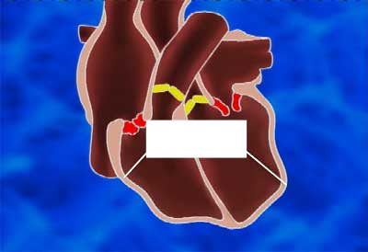  Heart muscle becomes thinner and less firm |  |  | Problem number 3:  The heart muscle becomes thinner with age and less firm. The pump’s efficiency therefore decreases.

