Solutions to the worksheet
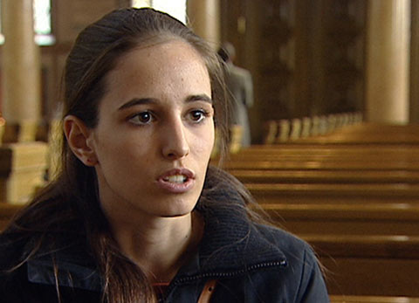

Dossier Religion

1. What do you think about the surveys? Which responses do you like best?
Individual answers.
2. What do you know about the Christian faith?
It was founded by Jesus of Nazareth, and the Bible is its main basis. The Ten Commandments.
3. When did Damaris Sanchez choose to be baptized and how does she practise her Christianity?
Not until she was 12 years old. She has been an altar server for eight years, but she does not take the Bible literally.
4. Why does Damaris think it is important to believe in something?
Her belief gives her answers to the questions of where human beings come from and where they are going.
5. What do you know about Islam?
In Islam, God is called Allah. Islam was founded by Mohammed, the place of worship is called a mosque and Ramadan is an important festival.
6. How was Hüseyn Ucmak introduced to Islam? And how does he practise his faith today?
He was introduced to Islam by his parents. He makes the five prayers at home in his room and attends Friday prayers at the mosque as often as possible.
7. How freely or how strictly does Hüseyn’s family follow Islam?
Hüseyn was allowed to make up his own mind about what and how he believes. This freedom is well established in the family: for example his mother wears a headscarf, but his sister does not.
8. What does Hüseyn think about the issue of Islam and violence?
He is against violence and condemns political groups that exploit Islam for their own purposes.
9. What do you know about Judaism?
Expulsion of the Jews; they gather in synagogues; circumcision; persecution; kosher food.
10. How does Elinor Biro practise the Jewish faith?
She is not orthodox and does not attend the synagogue regularly.

11. How strongly is Elinor influenced by her faith?
She feels her Judaism to be a big part of her life. She attended a Jewish primary school and can write and read Hebrew.
12. How do you feel about religion and faith?
Individual answers.

