Worksheet
*-9-+-+

Economy and society
Earning (1)

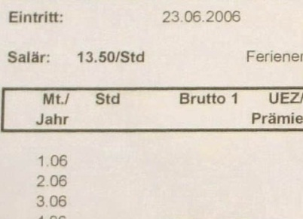 |  | - What are net earnings?  - What benefits does This Langenegger receive in addition to his pay?  - How much does This Langenegger's boss have to pay for This, on top of his wages?  - Which jobs in Switzerland are the highest-paying on average, and which are the lowest-paying?  - What is the approximate wage distribution in Switzerland?  - What do you think of incomes of a million francs and above?  - How does the head of the Economic Policy Directorate, Aymo Brunetti, justify wage differences?  - How great, statistically, are wage differences between men and women?  - What tips do youngsters give on how to earn more?  - How will This manage to earn more?
