worksheet
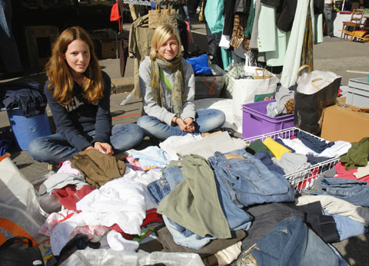

Economy and society
Selling (3)

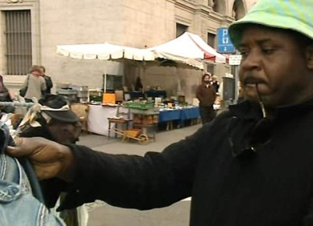 |  | - Have you ever sold anything? What was it?  - What do we usually exchange for goods and services?  - Why are well-known brands especially important to a sup-plier?  - Who does a producer first sell his goods to if, eventually, they are to be sold at a department store?  - What factors does a supplier have to consider for his goods to sell successfully?  - Can a salesperson influence a customer’s opinion?  - Why do buyer and seller depend on each other?  - Name five well-known brands. What price, quality, and prestige do you expect of them?  - Name a few brands that no longer exist.  - What happens if too many suppliers push onto a market?  - What do you do if a product or service is too expensive for you?
