Solutions to the worksheet
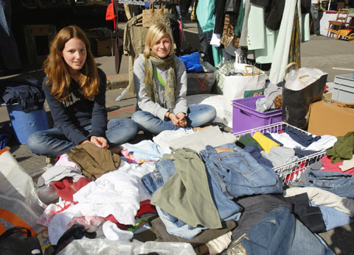

Economy and society
Selling (3)

1. Have you ever sold anything? What was it?
Individual answer

2. What do we usually exchange for goods and services?
We exchange money for them.

3. Why are well-known brands especially important to a sup-plier?
Brands implicitly promise a certain price, quality and prestige associated with a particular product.

4. Who does a producer first sell his goods to if, eventually, they are to be sold at a department store?
He sells them to an intermediary or middleman. The producer has no direct contact with the buyer or consumer.

5. What factors does a supplier have to consider for his goods to sell successfully?
For a start, his goods have to meet buyers’ expectations in terms of quality. The same goes for price. Additional factors are competition, demand, weather conditions, presentation as well as the salesperson’s helpfulness or a product’s brand name.

6. Can a salesperson influence a customer’s opinion?
Individual answer

7. Why do buyer and seller depend on each other?
A buyer cannot buy anything if a seller doesn’t sell anything, and a seller cannot sell anything as long as a buyer doesn’t buy anything. They require each other for an exchange to take place: that is, a seller offers something the buyer desires, and as a rule the buyer gives him money for it.

8. Name five well-known brands. What price, quality, and prestige do you expect of them?
Individual answer

9. Name a few brands that no longer exist.
Individual answers

10. What happens if too many suppliers push onto a market?
Competition arises, and prices usually drop as supply is too high.

11. What do you do if a product or service is too expensive for you?
Individual answers

