Worksheet

Economy and society
Making provision (4)

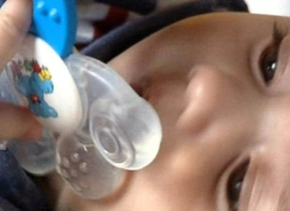 |  | - How can we provide for the future? What suggestions do the young people in the film make? What are your own ideas?  - What examples from the natural world does the film list? What examples can you think of?  - How does Anton Streit, the expert on old-age provision, ex-plain its basic principle?  - What purpose does an analysis of one’s financial situation serve?  - What is the AHV?  - How old is the AHV?  - What is the second pillar?  - What is the third pillar?  - What risks are there in old-age provision?  - What does Sonja Mehmann think of making provision?  - When do you want to start making provision for the future?  - How do you want to make provision?
