worksheet
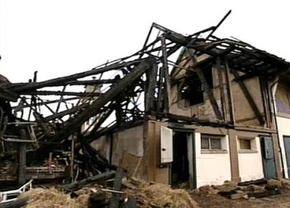
Economy and society

Insuring (6)

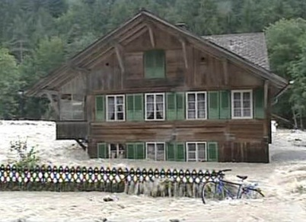 |  | - Who pays for storm damage on buildings?  - Which third-party insurance in Switzerland has a very low premium?  - What kind of insurance had Peter Saner taken out?  - What damage did his insurance company eventually cover?  - What are crash recorders for?  - Who was driving the Mini Cooper on the day of the accident?  - What three major groups of insurance are there?  - What kind of compensation have you claimed yet? Try and think of five examples.  - Why do we have to buy vignettes for our bicycles?  - Is it true that nuclear power plants need no insurance?  - Why do people take out insurance?  - How can Peter Saner influence the level of his car insurance premium?
