Solutions to the worksheet
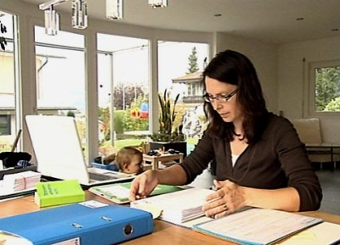

Economy and society
Adult learning (7)

1. List some incentives for adult learning.
Changes at work or home, changes in roles at work, and individual reasons.

2. Why would craftsmen in former times go on the «Walz»?
They would acquire many useful new skills.

3. Why do companies invest in training their employees?
To stay competitive: because professional areas constantly develop; because employees feel more supported and valued, which strengthens workplace relations.

4. What marks the beginning of further education?
A situation analysis

5. What are some key factors for choosing the best educational institution?
Fees, location, reputation, choice of courses, value for money

6. What further education does the Swiss government offer?
Degree courses at university and the Federal Institute of Technology, colleges of higher education, as well as professional education and training.

7. How can you avoid qualitatively poor courses?
By getting references beforehand and by obtaining information from the Internet.

8. What protection against inadequate providers does the Swiss Association for Adult Learning and the Swiss government offer?
Reputable providers are awarded certification – if their course content, goal and price-performance ratio are up to standard.

9. What changes may further education bring with it?
Financial and time pressures, a change in daily routines, possibly a change of residence.

10. What differences does André Schläfli note between men and women’s further education?
For women with a family, further education poses a much greater challenge; women also pay for their further education more often than men; women tend to attend courses offered on the market, but fewer courses with a diploma.

11. How can you find out more about adult learning?
Individual answer
12. What type of adult learning would interest you?
Individual answer

