Worksheet
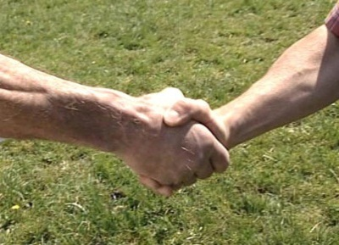

Economy and society
Trading (9)

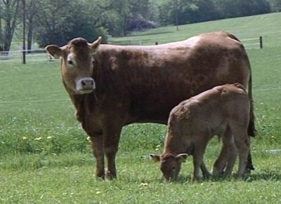 |  | - What sorts of goods are commonly traded in?  - What difference is there between a retailer and a wholesaler?  - What are the functions of intermediary Urs Jaquemet from the purchase of the cattle to their sale?  - What risks are there for intermediary Urs Jaquemet from the purchase of the cattle to their sale?  - How is a market price formed?  - What external factors can influence prices?  - What factors determine the price of a cow?  - What was the value of Switzerland’s exports and imports in 2008?  - Where are the headquarters of the World Trade Organization WTO located?  - When did Switzerland become a member of the WTO?  - How is the margin calculated?  - What are some defining characteristics of a good auctioneer?
