Worksheet
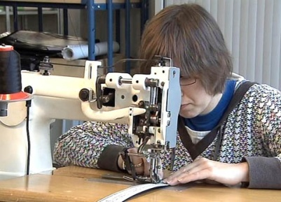

Economy and society
Producing (11)

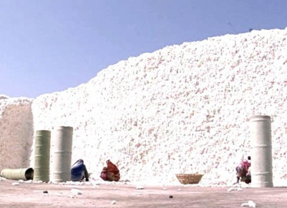 |  | - What production processes have you ever taken part in? Describe what that was like.  - The production of Primecut belts at Züriwerk is broken down into many individual steps. Why is that?  - What motivates Züriwerk employees?  - In what ways is mass production different from individual production? Name advantages and drawbacks of both production types.  - What different types of production factors feature in the film?  - What are the three business sectors and approximately what percentage of Swiss is employed in each sector?  - Name some of the greatest changes industrialization brought about.  - How is labour productivity measured, and how has it changed with regard to Swiss army knives in the last 50 years?  - In which periods of the 20th century did the Swiss GDP per capita fail to grow?  - What kinds of undesired negative effects can production processes have?  - What measures could be taken to combat the negative effects listed in question 10?  - What kind of product would you like to make yourself? How important would sustainability be for you?
