Solutions to the

worksheet
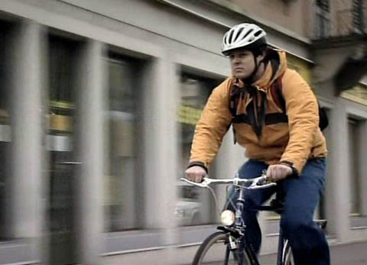 |  | English for Sek I, Sek II
 |  | Traffic – the rules of the road
12. The invisible cyclist

09:45 minutes
Two-track audio

1. Where is Christoph going on the night of his accident?
He is cycling to a martial arts training session.

2. What unusual profession has Christoph got?
He is an organ builder.

3. Briefly discuss the relative strength of cyclists in traffic.
Cyclists, in contrast to car drivers, are considered «weak» road users because of the severe injuries they often sustain in road accidents.

4. What accessories increase cyclists' visibility?
Reflectors

5. What colours should cyclists wear?
Light colours – cyclists are much easier to spot that way.

6. List the legal requirements for bicycle lights.
The following requirements are compulsory for bicycles:
Lights that don't flash – white in front, red in back.
Reflectors – white in front, red in back, with a reflecting area of at least 10 cm².
Yellow reflectors on pedals, front and back.

7. What do we call the generator of a bicycle's light?
Dynamo

8. What injuries do cyclists often sustain? How can they protect themselves?
Approximately 50 percent of all cyclists in accidents suffer head injuries. By wearing a helmet, the risk of such an injury can be drastically reduced.

9. How often do you ride your bike? When did you last cycle somewhere? What lights did your bicycle have?
Individual answers

10. Have you ever experienced a road accident – directly or indirectly? Describe what happened and what caused the accident.
Individual answers

