 |  |  |  | Worksheet
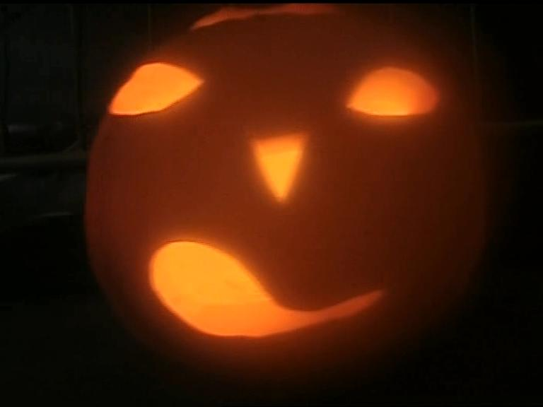 |  | English for Sek I, Sek II
 |  | Cultural phenomena
Halloween (7)

15:00 minutes

1. Where does the American Halloween originally come from?

2. What are the roots of Halloween?

3. Why do people celebrate Halloween? What is it about? Why do people wear spooky masks?

4. Where does the pumpkin lantern come from?

5. What does the name “Halloween” signify?.

6. What do you know about All Saints’ Day and All Souls’ Day? When and why were these holidays introduced?

7. How did Halloween come to Switzerland?

8. What do you know about the Halloween boom and the Halloween business?

9. What is your opinion about the American Halloween, about the Celtic Halloween, about the occult Halloween?

10. The young man from the gothic scene makes the following statement: “We are all going to rot one day.” What is your opinion of his statement?

11. Halloween is criticized by various sides. Who criticizes Halloween, and why?

12. Are you for or against Halloween? And why? What does Haloween mean to you?

