worksheet
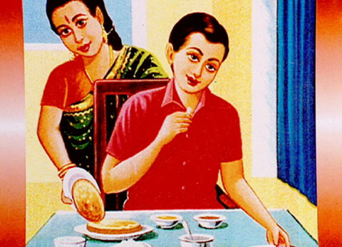
Cultural Phenomena

Manners (13)

28:45 minutes

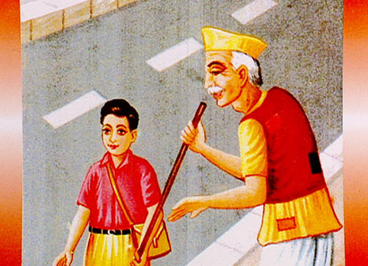 |  | - What are manners? Why do we need rules of behaviour?  - a) What rule of behaviour do you recognise in the first picture?  b) Give further examples of this rule!  c) Do you follow these rules? Give reasons  - a) What rule of behaviour do you recognise in the second picture?  b) Give further examples of this rule!  c) Do you follow these rules? Give reasons!  - a) What rule of behaviour do you recognise in the third picture?  b) Give further examples of this rule!  c) Do you follow these rules? Give reasons!  - a) What rule of behaviour do you recognise in the fourth picture?  b) Give further examples of this rule!  c) Do you follow these rules? Give reasons!
