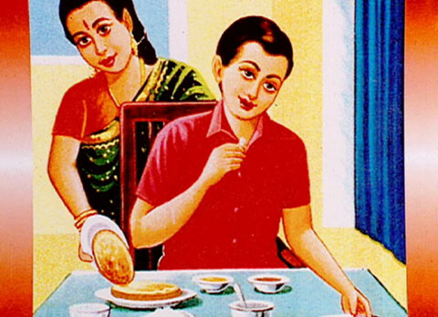
English for Sek I, Sek II

Cultural Phenomena
Manners (13)
28:45 minutes

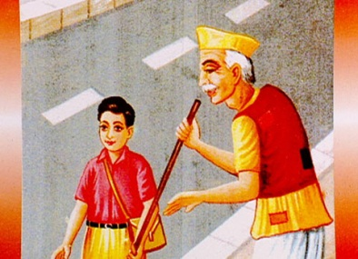
- What are manners? Why do we need rules of behaviour?
Thomas Eberle’s definition: Manners are unwritten rules that govern the way we live together. A few examples: Eating manners, respect for our fellow human beings, respect for our environment, no breach of the public order.

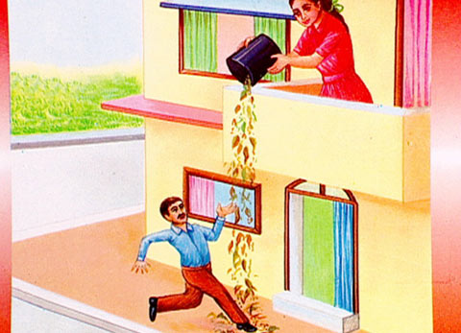
We need rules because unlike animals, our actions aren’t merely based on instincts and needs, but on standards which govern our lives together. Manners give us a sense of security and confidence because we know how to behave in different situations. If you break these codes of conduct, people react. You seldom have to go to prison or pay a fine. But people will avoid you, won’t invite you round any more or will make fun of you. In more serious cases, you may be expelled from school or be unable to find an apprenticeship.

- a) What rule of behaviour do you recognise in the first picture?
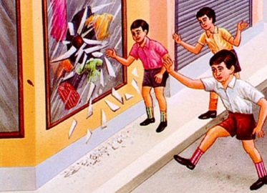
Eating manners

b) Give further examples of this rule!
Don’t use your fingers for eating, don’t chew with your mouth open, don’t smack, don’t talk with a full mouth, wash your hands before eating, don’t eat until everybody is at the table etc.

c) Do you follow these rules? Give reasons
(Individual answers)

- a) What rule of behaviour do you recognise in the second picture?
Respect for our fellow human beings

b) Give further examples of this rule!
Offering your seat to elderly people in the tram, addressing adults with “Sie”, let people get out of a bus or train before you get in, saying “thank you” and “you’re welcome” or “please", not talking loudly on the phone in the tram, standing correctly in a queue etc.

c) Do you follow these rules? Give reasons!
(Individual answers)

Manners

- a) What rule of behaviour do you recognise in the third picture?
Respect for the environment

b) Give further examples of this rule!
Don’t spit your chewing gum on the ground, don’t leave your rubbish lie or stand around, follow the marked paths in the forest, don’t leave the marked slopes etc.

c) Do you follow these rules? Give reasons!
(Individual answers)

- a) What rule of behaviour do you recognise in the fourth picture?
No breach of the public order

b) Give further examples of this rule!
Don’t skate/cycle/kickboard in the pedestrian zones

c) Do you follow these rules? Give reasons!
order to get down insects from branches.
(Individual answers)

