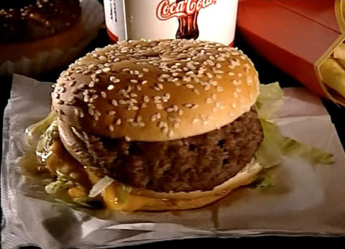
English for PS, Sek I und Sek II

Cultural Phenomena
Fast food (19)
13:45 minutes
Two-track audio

- Explain the historical background of fast food.
In the early Stone Age, 600,000 years ago, our ancestors had their own kind of fast food. On their hunting trips they ate berries or snails. Slain animals were eaten on the spot, raw.
It was only the use of fire that made people more sociable – cooking and eating was done together around the fireplace.
Historians found the first take-away bars in Roman times. Then, hot stews would be sold in the streets. 1,500 years later, during the Industrial Age, «fast eating» experienced a new boom. The first take-away stands sprang up in front of factories. The sausage, quick and easy to eat, was a cheap and fatty energy source for the workers. In this way, veal sausages became very popular in Europe while in the USA it was sausages in rolls – «hot dogs».
But in 1954, the mixer salesman Ray Kroc discovered the fast food restaurant owned by the McDonald brothers. Hamburgers eventually made Ray Kroc a millionaire 500 times over.
In the 70s and 80s burgers, and French fries migrated across the ocean to all parts of the world.
- What does fast food mean?
Fast food takes its name from its quick preparation. Fast food is neither healthy nor unhealthy. It is usually packed into cardboard- or plastic boxes.

- Report on the fastest eater in the animal kingdom.
The star-nosed mole is the fastest eater among all animals. It lives in marshy areas in North America, is unattractive and blind. With 22 tentacles projecting from its nose, the little mole can locate 13 types of prey in just one second. In a tenth of a second, it swallows an insect or worm.

- What do you know about the ketchup test?
At the SAM sensory testing laboratory in Zurich, fast food products are tested for large food companies from around the world. In the ketchup test, volunteers evaluate five varieties of ketchup by taste, consistency, colour and appearance. The food producers use the test results to help them decide which products to launch.

Fast food

- Is fast food addictive?
The head of the sensory testing laboratory, Martin Kern, thinks not. According to him, there are no substances in food that are addictive in the medical sense. But other food technologists are more critical. They are convinced that a particular combination of flavour carriers such as fat, salt and sugar can make fast food consumers addicted.

- Explain the term «ethno food».
Ethno food is fast food from other countries. Especially Middle-Eastern and Asian food is very popular.

- What does the film «Super size me» show, and what effect did it have?
The film author, Morgan Spurlock, lived exclusively on McDonald’s food for a whole month. Whenever they were offered, he chose the extra-large portions, the super size meals. Under constant medical supervision, he reported what fast food was doing to his body: Within 30 days Spurlock put on 11 kilograms, his liver grew fatty, his cholesterol level shot up by 65 points and his body fat increased from 11 to 18 percent. His risk of heart disease or heart failure nearly doubled, he felt exhausted and depressed, experienced mood swings and lost his sex drive.
When Spurlock's film was shown around the world in 2004, McDonalds came under pressure. It reacted by taking super size meals off its menu and by including salads instead.

- How are obese children treated?
In Switzerland today, every fifth child is strongly overweight – adipose – and the tendency is increasing. In the children's clinic in Davos, difficult cases are trimmed down to their ideal weight. Hooked up to medical appliances which constantly monitor their heart rate and oxygen intake, they are brought to their physical limits in order to break down their fat reserves.
These children's body fat ratio is too high, which means they have too much fat in proportion to their muscles and bones.
In the clinic kitchen, the children learn how to cook healthily: lots of vitamins, hardly any fat, vegetable broth instead of oil, and a minimum of salt – quite a change for them all.

- How good is these children's state of health?
It is alarmingly bad – they are considered seriously ill. Their blood pressure is too high, they have high blood sugar or a preliminary stage of it. In addition, they can't sleep properly, and their skeletal muscles cause them problems so that most of them have to take painkillers. Their quality of life is about as low as that of a cancer patient.

- Fast food and waste – what do you know about it?
Half of everything thrown away in public, into rubbish bins or onto the streets, comes from fast food meals. In the city of Bern, for example,

Fast food

5,000 tons of fast food waste lands up in bins; 100 tons are simply chucked onto the streets. The situation has turned so critical in Bern that the police now fine every offender with francs.

- How can you eat fast food and still stay healthy?
A hamburger with French fries once a week is no problem. If you don't eat fast food too often, and if you supplement it with salad or fruit, you can enjoy fast food and still stay healthy.

- In your view, what are the pros and cons of fast food?
(Individual answers)

