Worksheet
Cultural Phenomena

Laughing – crying (22)

14:15 minutes

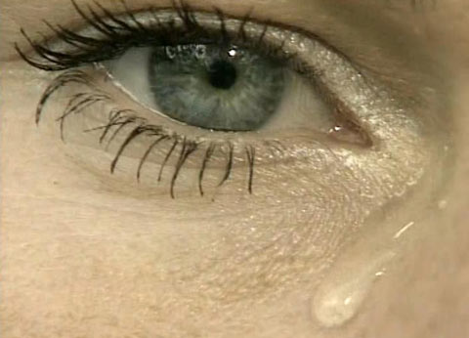 |  | - What significance did laughter have in the past?  - What is the status of laughter today?  - Explain the term «laughing club».  - How are children helped to get better at the children’s hospital in Zurich?  - What else have laughter scientists found out about laughing?  - Which animals other than human beings can laugh? What do you know about this?  - What significance did crying have in the past?  - Explain how crying changes as a child grows into an adult.  - Describe modern attitudes towards crying.  - When do people cry most frequently? Why?  - Laughter and crying are good for you! Explain.  - Write down your favourite joke!
