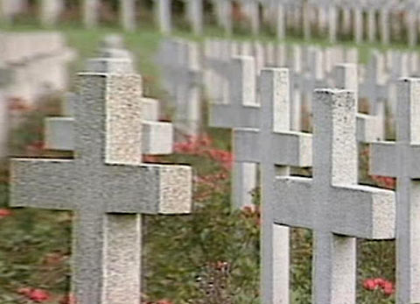
English for PS, Sek I and Sek II

Cultural Phenomena
Burials (25)

15:00 minutes

1. Which professional prepares the dead for the funeral?
An undertaker
2. At what temperature are bodies cremated at the crematorium?
800 degrees Celsius
3. Prehistoric tombs reveal a lot about everyday life at that time.
Why?
Families of the deceased put foodstuffs, jewellery and weapons into
tombs. These objects enable us to visualise everyday life then.
4. Describe how Hindus part from their dead.
Dead bodies are burnt and their ashes scattered over rivers.
5. How do funeral rites distinguish themselves between Muslims,
Jews and Christians?
Muslims and Jews bury their dead in graves facing the east, that is
Mecca or Jerusalem. In Islam the deceased must be buried within
24 hours. Before that, bodies are wrapped into cotton cloths.
6. Why is the percentage in cremations much higher in Zurich than
in the rest of the country?
(Individual answers; e.g. rural/urban differences)
7. How would you like to be buried?
(Individual answers)
8. From your grandparents or other people of their generation, find
out what used to be traditional funeral rites.
(Individual answers)
9. Visit a cemetery near where you live. Read the inscriptions on
the tomb stones. Note down those you like and which touch you.
(Individual answers)
10. Tell your classmates what you noticed in cemeteries abroad.
(Individual answers)

