Beantworte folgende Fragen zur Darstellung des Zweiten Weltkriegs.

Für welche Ereignisse lässt der Regisseur seine Zeitzeugen sprechen?
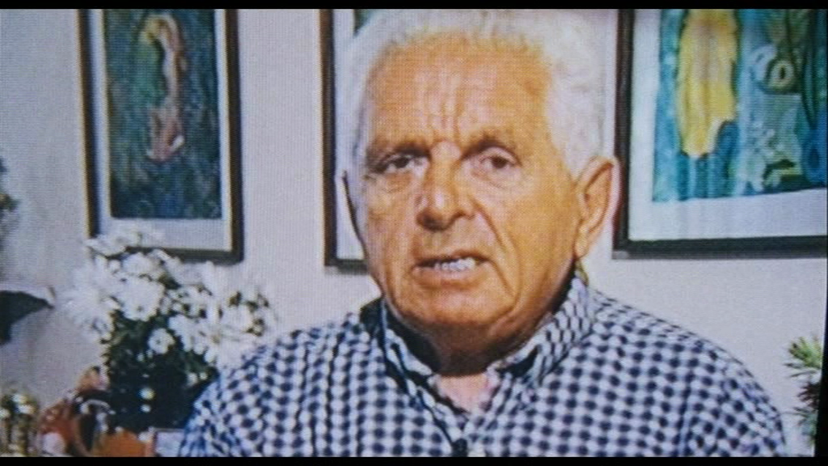
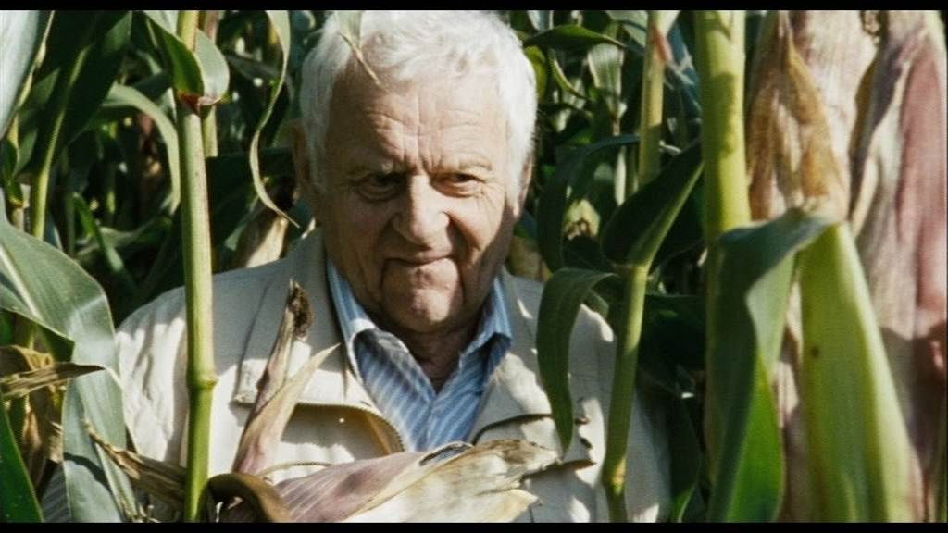
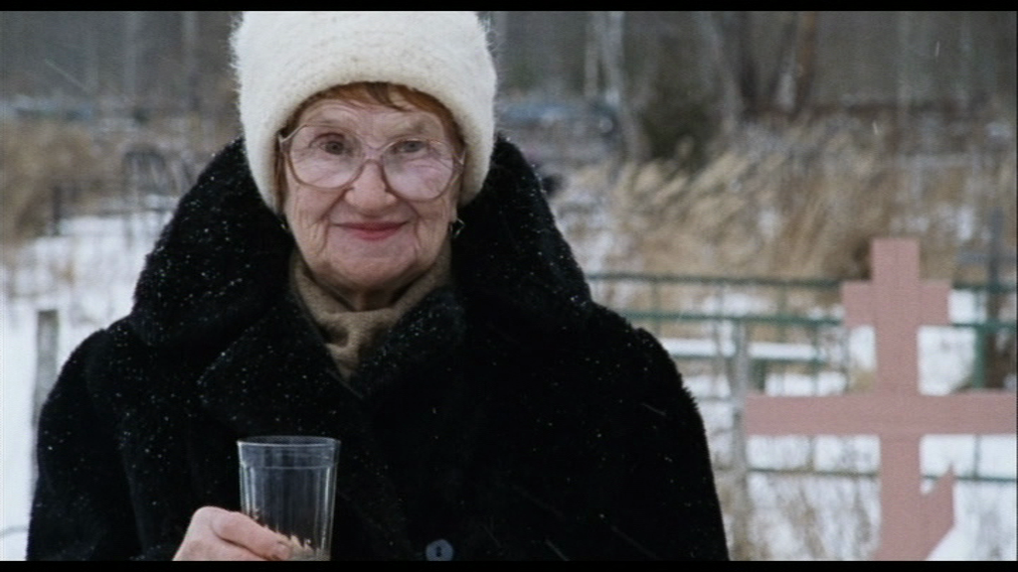
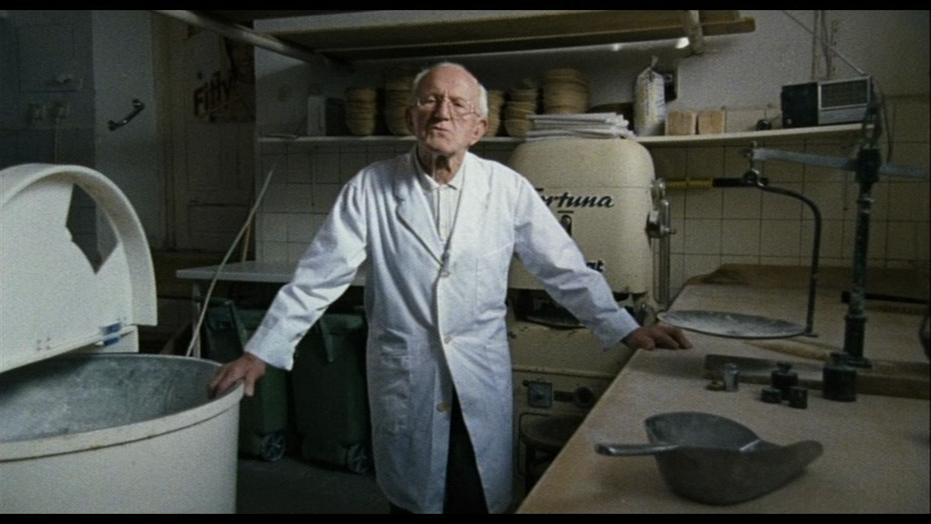
Franz Wienhart
_____________________________________________________________________________________________________________________________________________________________________________________________________________
Klavdia Matveevna Lobanova
_____________________________________________________________________________________________________________________________________________________________________________________________________________
Heinz Rüdiger
_____________________________________________________________________________________________________________________________________________________________________________________________________________
Liepke Distel
_____________________________________________________________________________________________________________________________________________________________________________________________________________
Welche Ereignisse werden mit Originalaufnahmen ergänzt?
________________________________________________________________________________________________________________________________________________________________________________________________________________________________________________________________________________________
Wie werden die historischen Aufnahmen in den Film integriert?
________________________________________________________________________________________________________________________________________________________________________________________________________________________________________________________________________________________
Wie hat der Autor die Interviews geschnitten?
________________________________________________________________________________________________________________________________________________________________________________________________________________________________________________________________________________________
Welche Haltung nimmt der Regisseur gegenüber den Ereignissen und Gesprächspartnern ein? Wie «wertet» der Film im Allgemeinen?
________________________________________________________________________________________________________________________________________________________________________________________________________________________________________________________________________________________
Analysiere im Speziellen die Sequenz mit dem jüdischen «Bäcker» Liepke Distel: Was suggeriert der Regisseur durch die Gegenschnitte zwischen Franz Wienhart und Liepke Distel?
________________________________________________________________________________________________________________________________________________________________________________________________________________________________________________________________________________________
Suchen in deinem Geschichtsbuch und im Internet erklärende und weiterführende Informationen zu folgenden Ereignissen und Persönlichkeiten.
Der deutsche Einfall in Polen, Hintergründe und Verlauf
____________________________________________________________________________________________________________________________________________________________________________________________________________________________________________________________________________________________________________________________________________________________________________________________________________________________________
________________________________________________________________________________________________________________________________________________________________________________________________________________________________________________________________________________________________________________________________________________________________________________________________________________________________________________________________________________________________________________________________________________________________________________
Die Belagerung Leningrads, Hintergründe und Verlauf
____________________________________________________________________________________________________________________________________________________________________________________________________________________________________________________________________________________________________________________________________________________________________________________________________________________________________
________________________________________________________________________________________________________________________________________________________________________________________________________________________________________________________________________________________________________________________________________________________________________________________________________________________________________________________________________________________________________________________________________________________________________________
General Schukow
______________________________________________________________________________________________________________________________________________________________________________________________________________________________________________________________________________________________________________________________________________________________________________________________________________________________________________________________________________________________________________________________________________________________________________________________________________________________________________________________________________________________________________________________________________________________________________________________________________________________________________________________________________________________________________________________________________
General Wilhelm Ritter von Leeb
______________________________________________________________________________________________________________________________________________________________________________________________________________________________________________________________________________________________________________________________________________________________________________________________________________________________________________________________________________________________________________________________________________________________________________________________________________________________________________________________________________________________________________________________________________________________________________________________________________________________________________________________________________________________________________________________________________

