Beantworte folgende Fragen zur Darstellung der Jugoslawienkriege zu Beginn der 90er Jahre.

Für welche Ereignisse lässt der Regisseur seine Zeitzeugen sprechen?
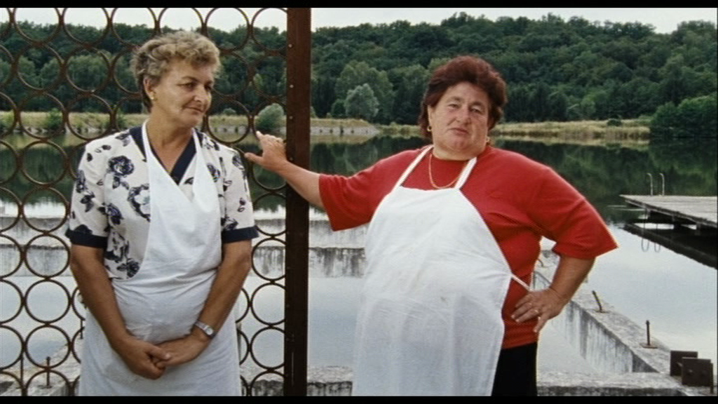
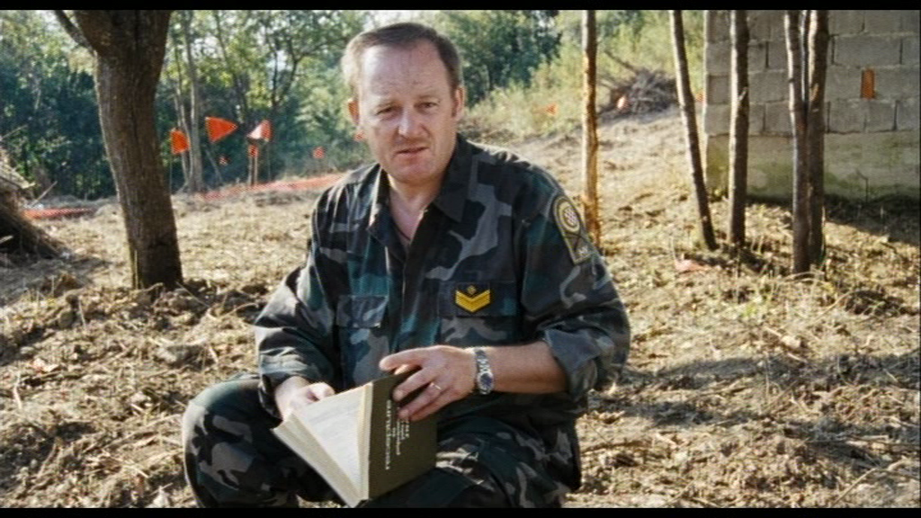
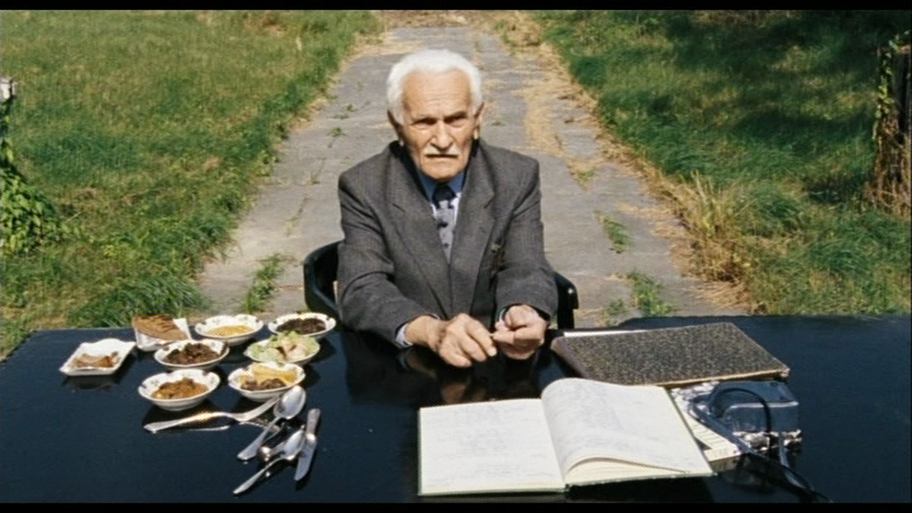
Branko Trbovich
_____________________________________________________________________________________________________________________________________________________________________________________________________________
Mladen Vlachyna
_____________________________________________________________________________________________________________________________________________________________________________________________________________
Branka Mudrenic & Ankica Pavlovic
_____________________________________________________________________________________________________________________________________________________________________________________________________________
In welchem Verhältnis stehen die Gesprächspartner zueinander?
________________________________________________________________________________________________________________________________________________________________________________________________________________________________________________________________________________________
Wie äussern sie sich die Gesprächspartner zur Gegenpartei?
________________________________________________________________________________________________________________________________________________________________________________________________________________________________________________________________________________________
Wie hat der Autor die Interviews geschnitten?
________________________________________________________________________________________________________________________________________________________________________________________________________________________________________________________________________________________
Welche Haltung nimmt der Regisseur gegenüber den Ereignissen und Gesprächspartnern ein? Wie «wertet» der Film im Allgemeinen?
________________________________________________________________________________________________________________________________________________________________________________________________________________________________________________________________________________________

Suchen in deinem Geschichtsbuch und im Internet erklärende und weiterführende Informationen zu folgenden Ereignissen und Persönlichkeiten.
Josip Broz Tito
____________________________________________________________________________________________________________________________________________________________________________________________________________________________________________________________________________________________________________________________________________________________________________________________________________________________________
________________________________________________________________________________________________________________________________________________________________________________________________________________________________________________________________________________________________________________________________________________________________________________________________________________________________________________________________________________________________________________________________________________________________________________
Die Folgen von Titos Tod – Der Zerfall der Republik Jugoslawien
____________________________________________________________________________________________________________________________________________________________________________________________________________________________________________________________________________________________________________________________________________________________________________________________________________________________________
________________________________________________________________________________________________________________________________________________________________________________________________________________________________________________________________________________________________________________________________________________________________________________________________________________________________________________________________________________________________________________________________________________________________________________
Die Schlacht um Vukovar
______________________________________________________________________________________________________________________________________________________________________________________________________________________________________________________________________________________________________________________________________________________________________________________________________________________________________________________________________________________________________________________________________________________________________________________________________________________________________________________________________________________________________________________________________________________________________________________________________________________________________________________________________________________________________________________________________________

