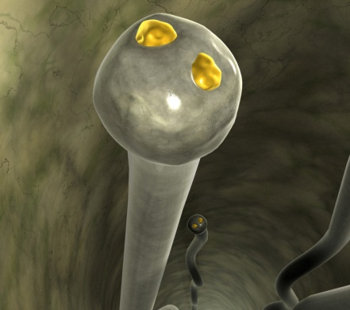 | ___________________________________________________________________________________________________________________________________________________________________________________________________________________________________________________________________________________________________________________________________________________________________________________

__________________________________________________________________________________________________________________________________________________________________________________________________________________________________________________________________________________________________________________________________________________________________________________________ | 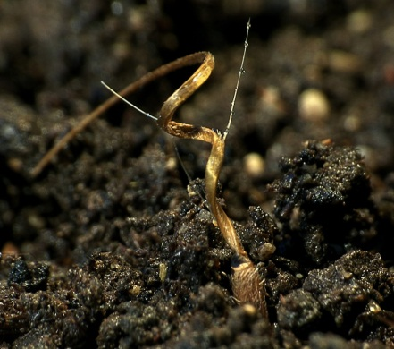

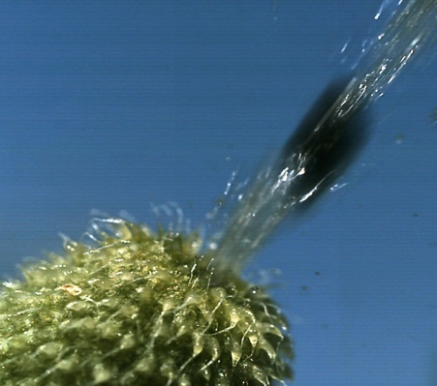 | ___________________________________________________________________________________________________________________________________________________________________________________________________________________________________________________________________________________________________________________________________________________________________________________

__________________________________________________________________________________________________________________________________________________________________________________________________________________________________________________________________________________________________________________________________________________________________________________________ |  | 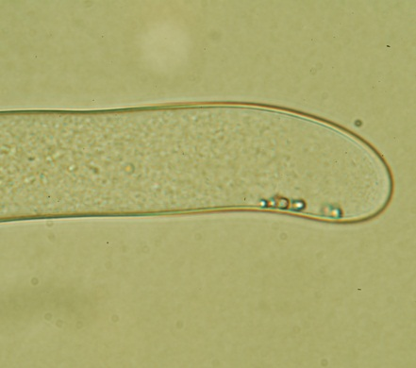
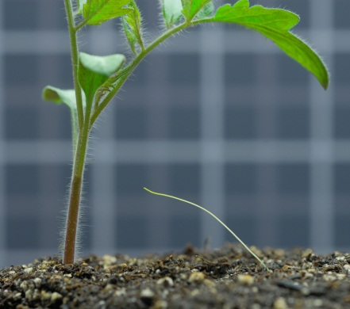 | ___________________________________________________________________________________________________________________________________________________________________________________________________________________________________________________________________________________________________________________________________________________________________________________

__________________________________________________________________________________________________________________________________________________________________________________________________________________________________________________________________________________________________________________________________________________________________________________________ | 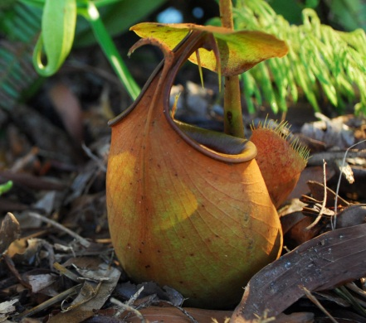

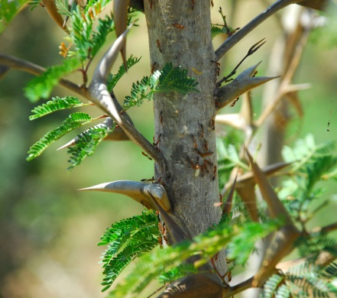 | ___________________________________________________________________________________________________________________________________________________________________________________________________________________________________________________________________________________________________________________________________________________________________________________

__________________________________________________________________________________________________________________________________________________________________________________________________________________________________________________________________________________________________________________________________________________________________________________________ | 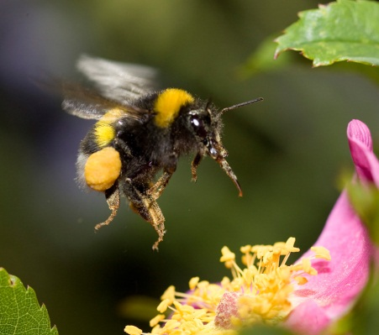
 | Alle Bilder: Kluge Pflanzen

