worksheet
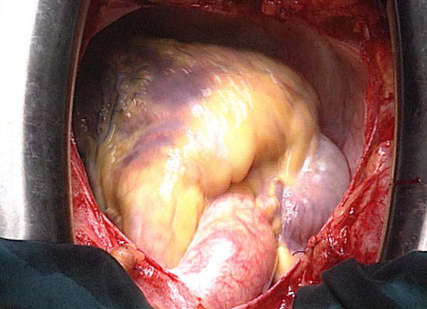

Dossier Heart
The pump

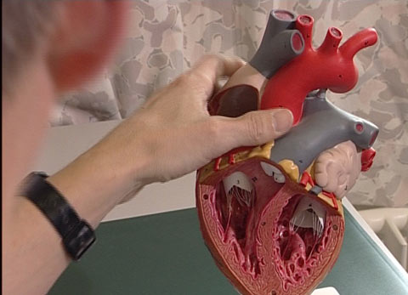 |  | - How many times does our heart beat in one day?  - How much blood does it pump around our body in one day?  - How many times (on average) does an adult’s heart beat during sleep?  - How many times (on average) does an adult’s heart beat during strenuous physical effort?  - What are the functions of our heart?  - Explain the pump function of the heart and the blood circulation.  - When does the heart of a human being begin to beat for the first time?  - What are the differences between the heart of a baby and an adult’s heart?  - How many times (on average) does the heart of an old person beat?  - Give three degenerative heart failures.  - Why are heart and circulatory diseases the number one cause of death in Switzerland?  - Give three methods to treat and/or cure heart diseases.
