Solutions to the worksheet
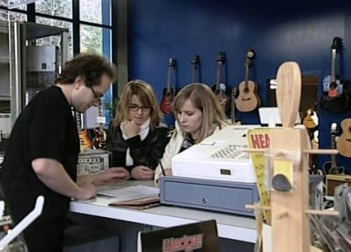

Economy and society
Renting (5)

1. What are the advantages of renting, according to economist Donato Scognamiglio?
You don't need a great deal of money at a time. You are more flexible and less tied down.

2. Name some odd or unusual things that can be rented.
Whole football stadiums, submarines for filming a movie, islands, a personality for dinner, a castle, men and women (prostitutes, call girls, call boys), works of art and paintings, graves, etc.

3. What factors determine the rent?
Supply and demand, but also the location of a home or the income tax rate in a particular place of residence.

4. What criteria are important for Angela in selecting a music shop?
The music shop has to be easy to reach. Her band has to be able to test the equipment beforehand – for example, the pod on her guitar. And the staff at a shop has to be willing to advise the band.

5. What are Donato Scognamiglio's tips for young renters?
Not to rent anything on your own, but to take someone along.
To show someone the contract before signing it.
To remember that there may be additional costs and that a deposit may have to be paid.

6. Even the Bible mentions renting – in which famous story? What is rented?
In the story of King Solomon he has to hire workers to build a temple.

7. What did the Romans hire and rent?
Slaves, vases, wine casks and houses

8. Name three special forms of rental.
Leasing in agriculture, leasing of goods, credits

9. What issues frequently lead to disputes between landlord and tenant?
Damage – who caused it and who has to pay for it;
Money – for example, if you feel a rent increase isn't fair or if the rent is generally too high;
Rules of the house – use of the laundry room or breach of the peace;
Rows with neighbours

10. Imagine renting something: would you do it like Caprice, or would you do it differently?
Individual answer
11. Of all things, what would you most likely rent?
Individual answer

