Solutions to the worksheet
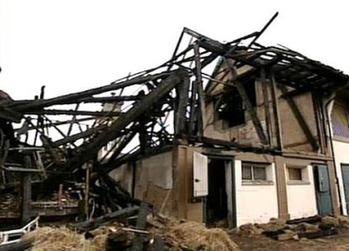
Economy and society

Insuring (6)

1. Who pays for storm damage on buildings?
Building insurance

2. Which third-party insurance in Switzerland has a very low premium?
Third-party insurance for cyclists. In Switzerland it costs just two cents a day, because so many people buy it, and because the possible damage is relatively limited.

3. What kind of insurance had Peter Saner taken out?
He had taken out fully comprehensive car insurance.

4. What damage did his insurance company eventually cover?
The total loss of his car, two new marker posts

5. What are crash recorders for?
They are simple tachographs, which record data during a drive. In case of an accident, the data can be analysed.

6. Who was driving the Mini Cooper on the day of the accident?
Benjamin, Peter's brother

7. What three major groups of insurance are there?
Asset insurance, property insurance and social insurance

8. What kind of compensation have you claimed yet? Try and think of five examples.
Individual answer

9. Why do we have to buy vignettes for our bicycles?
The bike vignette acts as a third-party insurance policy. In case of a loss event, the insurance will cover the damage.

10. Is it true that nuclear power plants need no insurance?
Wrong. It is compulsory for nuclear power plants to be insured against radiation accidents.

11. Why do people take out insurance?
To protect themselves against financial loss if damage occurs.

12. How can Peter Saner influence the level of his car insurance premium?
By taking part in a skid control course, by having a crash recorder installed.

