worksheet
Cultural Phenomena

Hair (6)

14:15 minutes

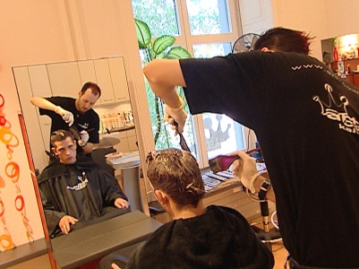 |  | - How many hairdresser’s shops are there in Switzerland?  - In what period did women wear their hair under a modest head covering?  - In the sixties, the hippies had long hair. What did it signify?  - What is ascribed to people with white hair?  - Nuns hide their hair. What does this signify?  - How important is your hair-style for you?  - What kind of hair-styles do you prefer?  - Does hair on the body irritate you?
