worksheet
Cultural Phenomena

Hello and Good-bye (15)

14:15 minutes

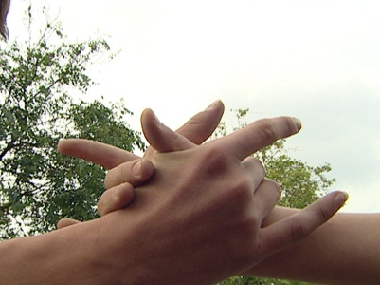 |  | - What do greetings mean to you personally?  - Do you use different forms of greeting when you meet different kinds of people?  - Where does the word «greeting» come from? What exactly does it mean?  - Greeting rituals reflect human relations in many ways. List four examples of how they do so.  - What meanings can a handshake have?  - Where did the fashion of exchanging kisses come to us from  - What are the functions of a greeting for the hip hoppers interviewed in the film?  - Describe various forms of greeting which make differences between people’s status clear.  - Where does probably the most moving farewell scene in movie history take place?  - What are Humphrey Bogart’s final words in this film?  - According to the psychologist Allan Guggenbühl, why are many young people looking for a connection with death?  - Do you agree with what Allan Guggenbühl says?  - How would you describe your own relationship with death?  - Do you agree that for each human being death really is the final parting and birth the first greeting?

