Worksheet
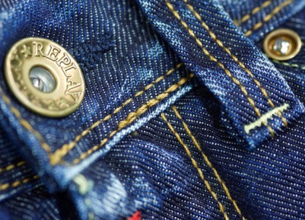
Cultural Phenomena

Blue jeans (17)

14:30 minutes

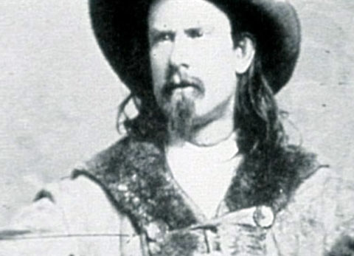 |  | - Who manufactured working clothes from canvas in 1850?  - Which name of an Italian harbour city is hidden in the word «jeans»?  - Which plant gives blue jeans their characteristic blue colour?  - Why do jeans fade to white in some places after being worn for some time?  - Can you remember, which countries produce which components of jeans? Which manufacturing steps in the production process take place in which countries?  - Dou you know any other product where individual manufacturing steps take place in different countries?  - On what occasions, in your view, would wearing jeans be inappropriate?  - How important are label jeans to you? Why?  - What would you never wear?
