Worksheet
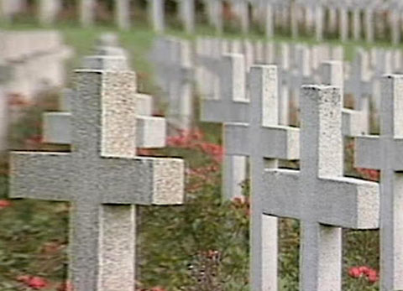
Cultural Phenomena

Burials (25)

15:00 minutes

- Which professional prepares the dead for the funeral?

- At what temperature are bodies cremated at the crematorium?
- Prehistoric tombs reveal a lot about everyday life at that time. Why?

- Describe how Hindus part from their dead.

- How do funeral rites distinguish themselves between Muslims, Jews and Christians?

- Why is the percentage in cremations much higher in Zurich than in the rest of the country?

- How would you like to be buried?
- From your grandparents or other people of their generation, find out what used to be traditional funeral rites.
- Visit a cemetery near where you live. Read the inscriptions on the tomb stones. Note down those you like and which touch you.
- Tell your classmates what you noticed in cemeteries abroad.

