While watching 00:22-05:50
Exercise 1: Watch the first two scenes and bring the pictures into the right order.
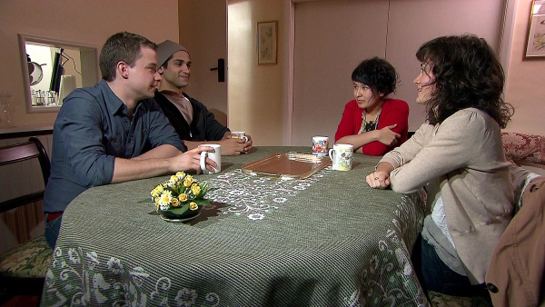  8 |  | 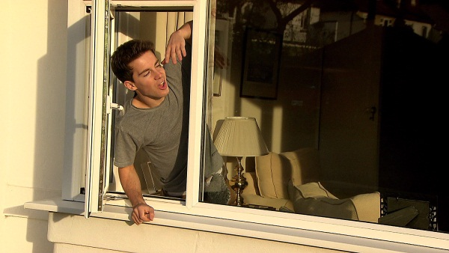  2
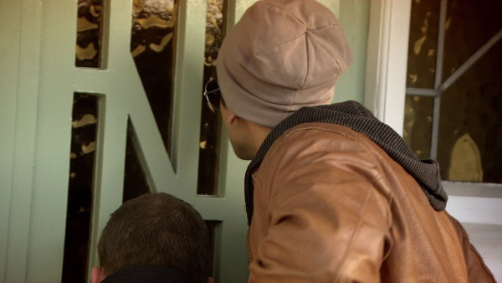  1 |  | 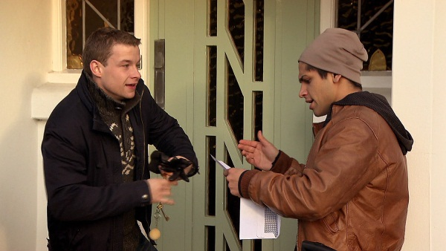  4
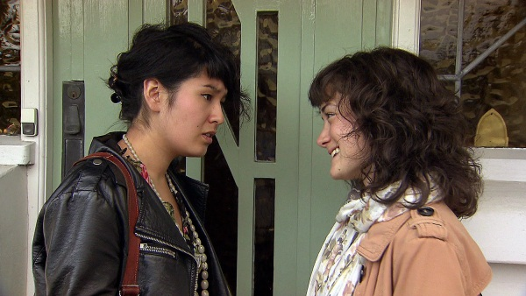  7 |  | 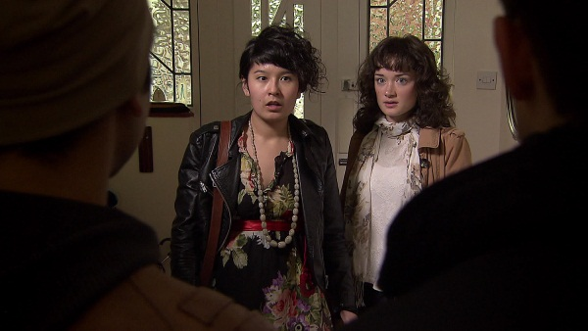  6
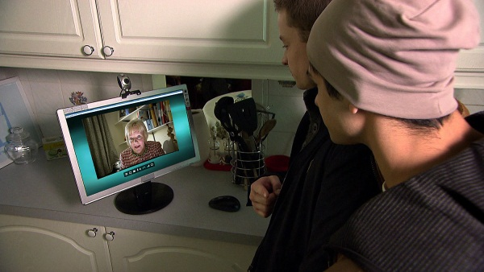  5 |  | 3
While watching 00:22-05:50
Exercise 2: Watch the same scenes again and check your answers.

Exercise 3: Match each picture with the appropriate sentences from the list on the next page. Attention: Some pictures have more than one matching sentence and not every sentence matches with a picture.
Exercise 4: Are you up for a bigger challenge? Are you confident enough? Write your own summary for each picture.

1. | Nino and Hannes arrive at No. 2 Silverleaf Gardens but nobody opens the door.
2. | Their neighbour Phil finally tells them that their landlady is in Ireland.
3. | Phil hands them an envelope with the keys to Lily’s house.
4. | There‘s a note from Lily in the envelope, but it‘s addressed to Elizabeth and Holly
5. | A ringing noise from a computer alerts them to a webcam call from Lily.  Lily informs the boys that the girls will arrive at six o‘clock.
6. | When the girls arrive, they ask for a word in private.
7. | Elisabeth tells Holly that she doesn‘t like the two guys in the house.  Holly can convince Elizabeth to give it a try.
8. | When the boys have served tea, the four of them talk a little bit.

While watching 05:50-09:53
Exercise 5: Watch the rest of the movie and decide if the sentences are correct or false.

t | f
x |  | The girls say that they are willing to share the house with the boys.
 | x | Hannes explains that he will be doing an eight month course on how to build a flying speedboat.
x |  | Nino suggests that the boys can sleep in a tent in the garden.
x |  | Holly is doing a course on teaching English as a foreign language.
x |  | Nino says he‘s looking for a job.
 | x | Nino sets out to finish cooking the fish.
 | x | Elizabeth wants to become a doctor.
 | x | As they are talking, an e-mail from Lily arrives.
x |  | She has left shepherd‘s pie for her lodgers to eat.
 | x | Nino has come to Brighton to visit his relatives.
Exercise 5: You now know which sentences are incorrect. Write them correctly.
Hannes explains that he will be doing an eight month course at Sussex university and research how a robot can learn different languages by lipreading.
Nino doesn’t know what a shepherd’s pie is.
Elizabeth is kind of an artist.
As they are talking a fax from Lily arrives.
Nino has come to Brighton to look after Hannes

