Before watching
Exercise 1 Have a look at the «wordle» below. What could happen in episode 2? Make 5 predictions and write them down.
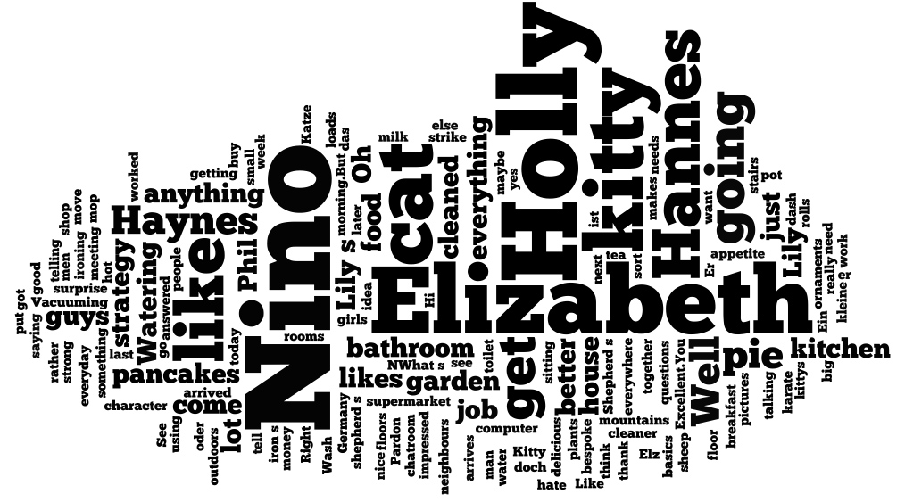
Predictions
____________________________________________________________________________________________________________________________________________________________________________________________________________________________________________________________________________________________________________________________________________________________________________________________________________________________________________________________________________________________________________________________________________________________________________________________________________________________________________________________________________________________________________________________________________________________________________________________________________________________________________________

