While watching 05:10-07:02
Exercise 1 What kind of household tasks do you have to take care of when living in a house? What kind of special household tasks are mentioned in the scene? Can you find them all?
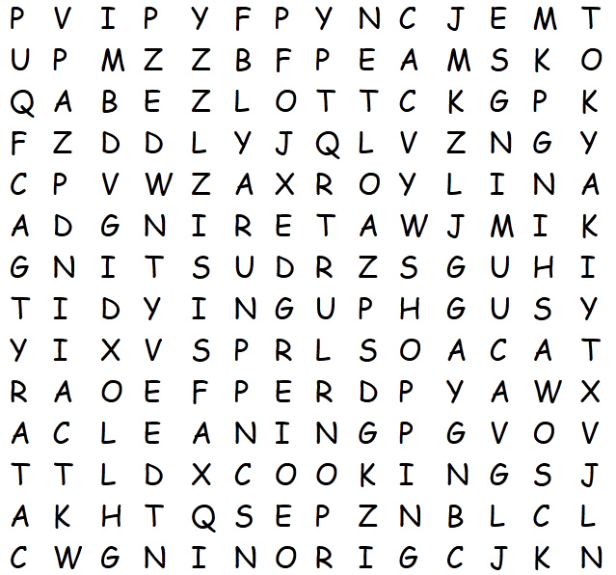 |  | CLEANING  COOKING  DUSTING  IRONING  SHOPPING  TIDYING UP  VACUUMING  WASHING  WATERING
CNAIGLEN
OOKICGN
NSDUTIG
NNOIIGR
PGNISPHO
IPY UDTING
AVCMNIGUC
WIHASNG
GWAETRIN

Exercise 2: Watch the scene «strategy meeting» and decide, which of the household tasks Elizabeth, Holly, Hannes and Nino are talking about. Who is responsible for which task?
_____________________________________________________________________________________________________________________________________________________________________________________________________________________________________________________________________________________________________________________________________________________________________________________________________________________________________________________________________________________________________________________________________________________________________________________________________________________________________________________________________________________________________________________________________________________________________________________________________________________________________________________________________________________________________________________________________________________________________________________________________________________________________________________________________________________________________________________________________________________________________________________________________________________________________________________________________________________________________________________________________________________________________________________________________________ |  | 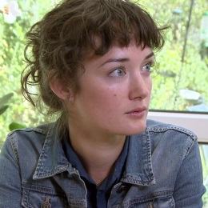

Exercise 3: Do you remember the arguments and excuses the four characters use in order to avoid doing the household tasks?
______________________________________________________________________________________________________________________________________________________________________________________________________________________________________________________________________________________________________________________________________________________________________________________________________________________________________________________________________________________________________________________________________________________________________________________________________________________________________________________________________________________________________________________________________________________________________________________________________________________________________________________________________________________________________________________________________________________________________________________________________________________________________________________________________________________________________________________________________________________________________________________________________________________________________________________________________________________________________________________________________________________________________________________________________________________________________________________________________________________________________________________________________________________________________________________________________________________
Exercise 4: Explain in your own words the two different meanings of the word «kitty».
____________________________________________________________________________________________________________________________________________________________________________________________________________________________________________________________________________________________________________________________________________________________________________________________________________________________________________________________________________________________________________

