After watching, grammar
Exercise 1 Put the verbs between brackets in the correct form. Use either present simple or present continuous.
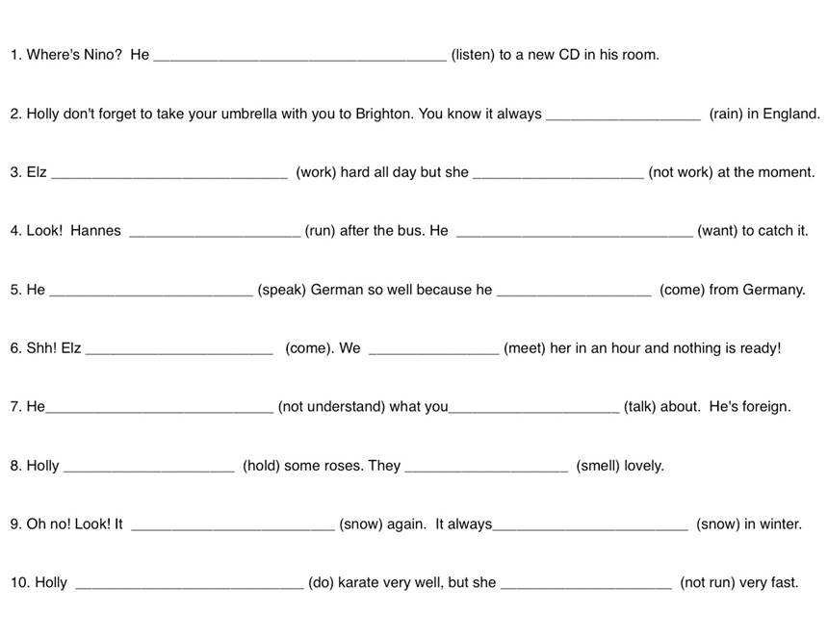
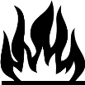
Exercise 2 Explain in your own words how to find the correct form of the present tense forms.

Exercise 3 Produce similar sentences with blanks as in exercise 1. Give the sentences to a classmate. Can he/she find the correct present tense form? Discuss your results.

Ask your teacher if you’re not sure whether your sentences are correct (before giving them to your classmate).
__________________________________________________________________________________________________________________________________________________________________________________________________________________________________________________________________________________________________________________________________________________________________________________________________________________________________________________________________________________________________________________________________________________________________________________________________________________________________________________________________________________________________________________________________________________________________________________________________________________________________________________________________________________________________________________________________________________________________________________________________________________________________________________________________________________________________________________________________________________________________________________________________________________________________________________________________________________________________________________________________________________________________________________________________________________________________________________________________________________________________________________________________________________________________________________________________________________________________________________________________________________________________________________________________________________________________________________________

