Historische Quelle zur restriktiven Flüchtlingspolitik der Schweizer Behörden

Auftrag: Erarbeiten Sie einen ca. 2-3minütigen Vortrag zu einer der folgenden Personen aus dem Film
Die Informationen beziehen Sie aus dem Film oder aus dem Internet/Geschichtsbüchern.

Notieren Sie sich zu ihrer Person folgende Aspekte:

- wichtigste Lebensstationen
- Erlebnisse an der Schweizer Grenze
- Motive ihres Handelns, Lebenshaltung
- Meinungen etc.
Alfons Eigenmann und sein Vater  (1938 Zollbeamter in Diepolsau)  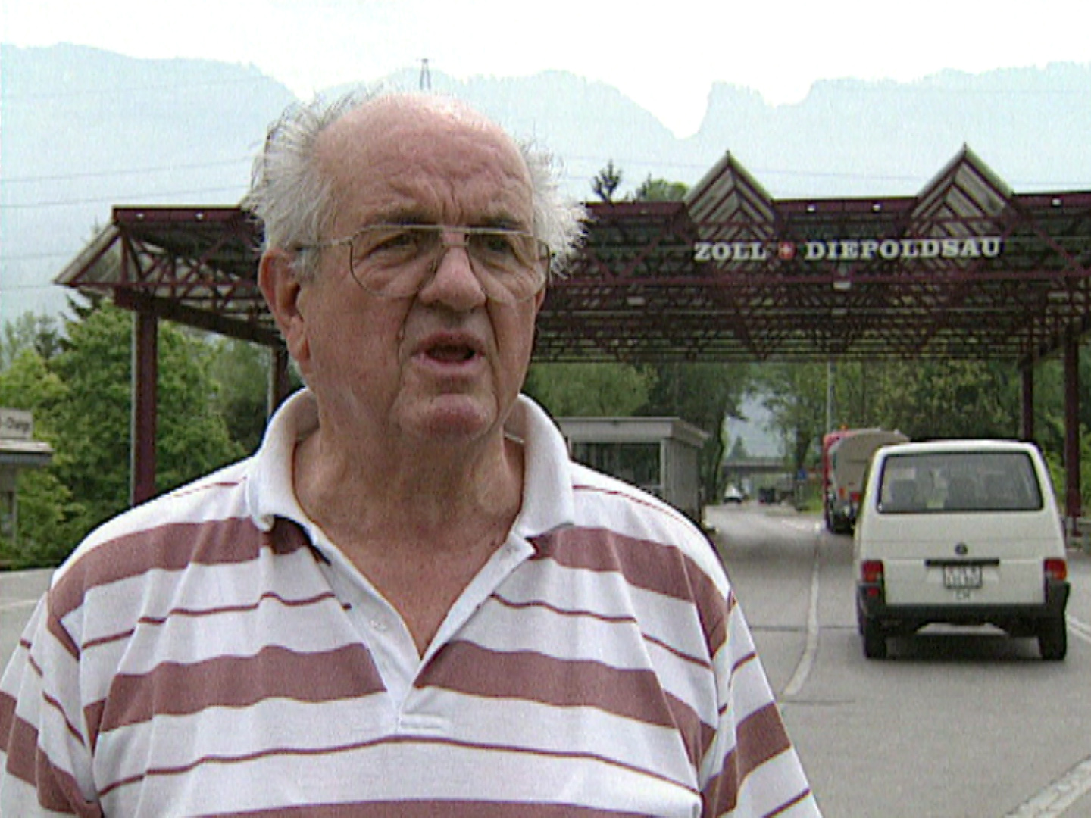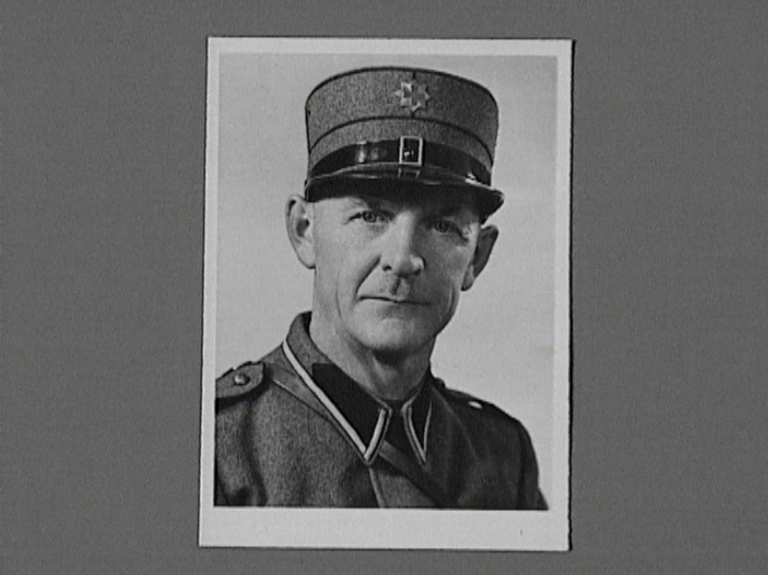 | Maria Untersanden, Tochter des Fluchthelfers Johann Spirig  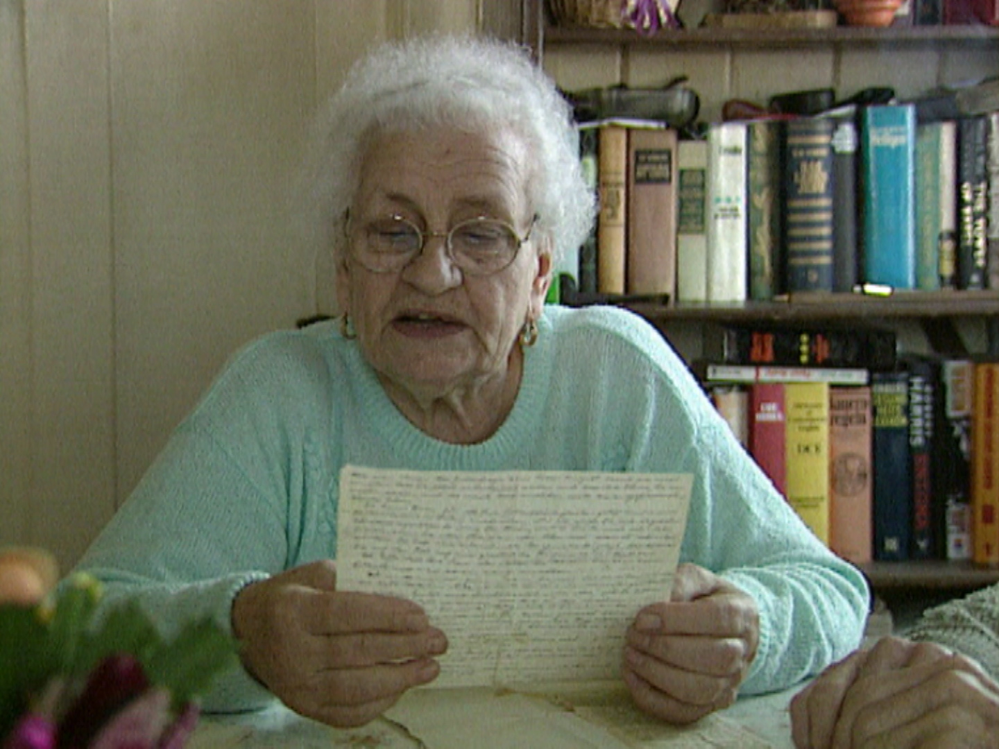
________________________________________________________________________________________________________________________________________________________________________________________________________________________________________________________________________________________________________________________________________________________________________________________________________________________________________________________________________________________________________________________________________________________________________________________________________________________ | ________________________________________________________________________________________________________________________________________________________________________________________________________________________________________________________________________________________________________________________________________________________________________________________________________________________________________________________________________________________________________________________________________________________________________________________________________________________

Jakob Spirig  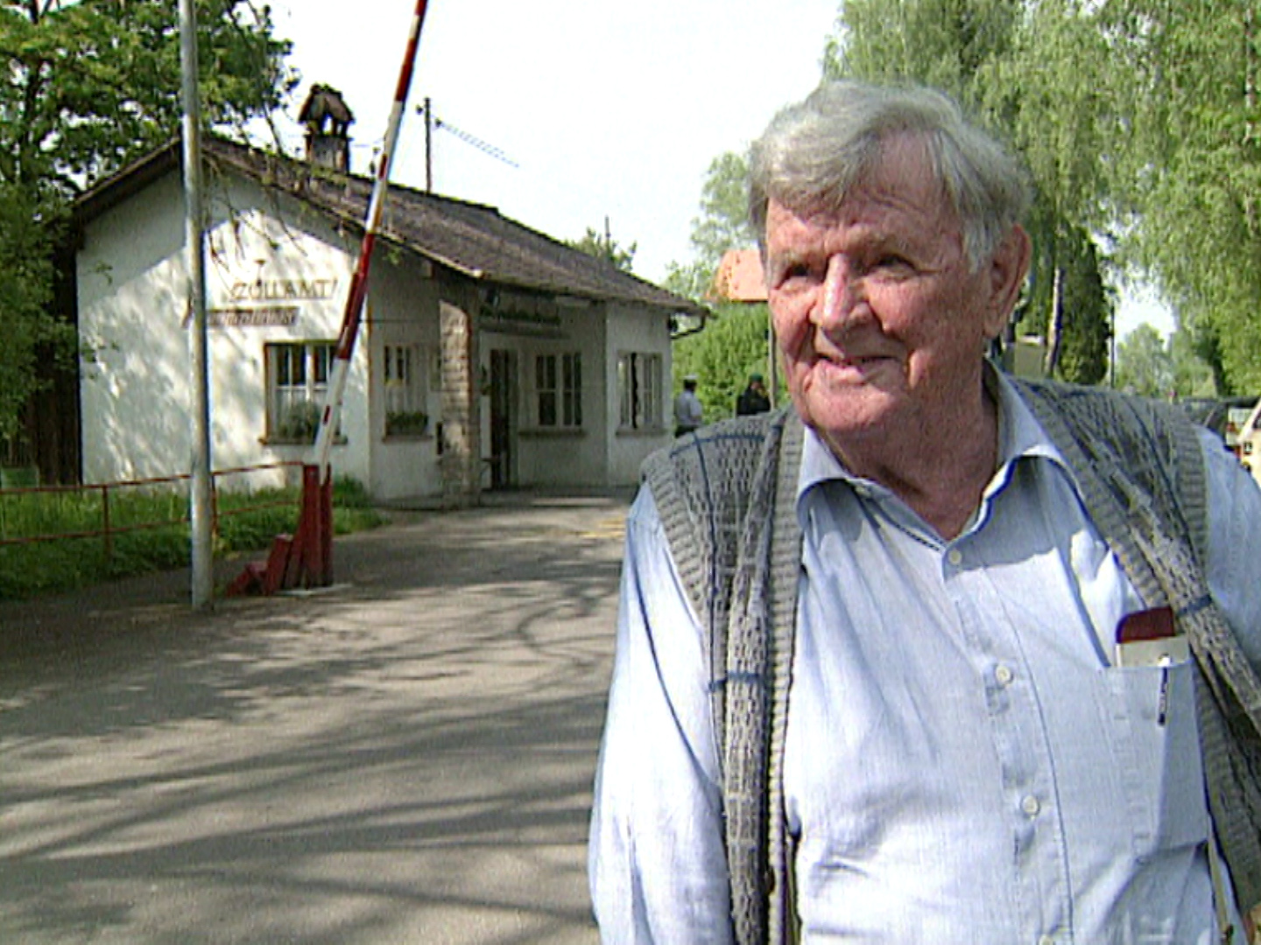 | Hans Weder  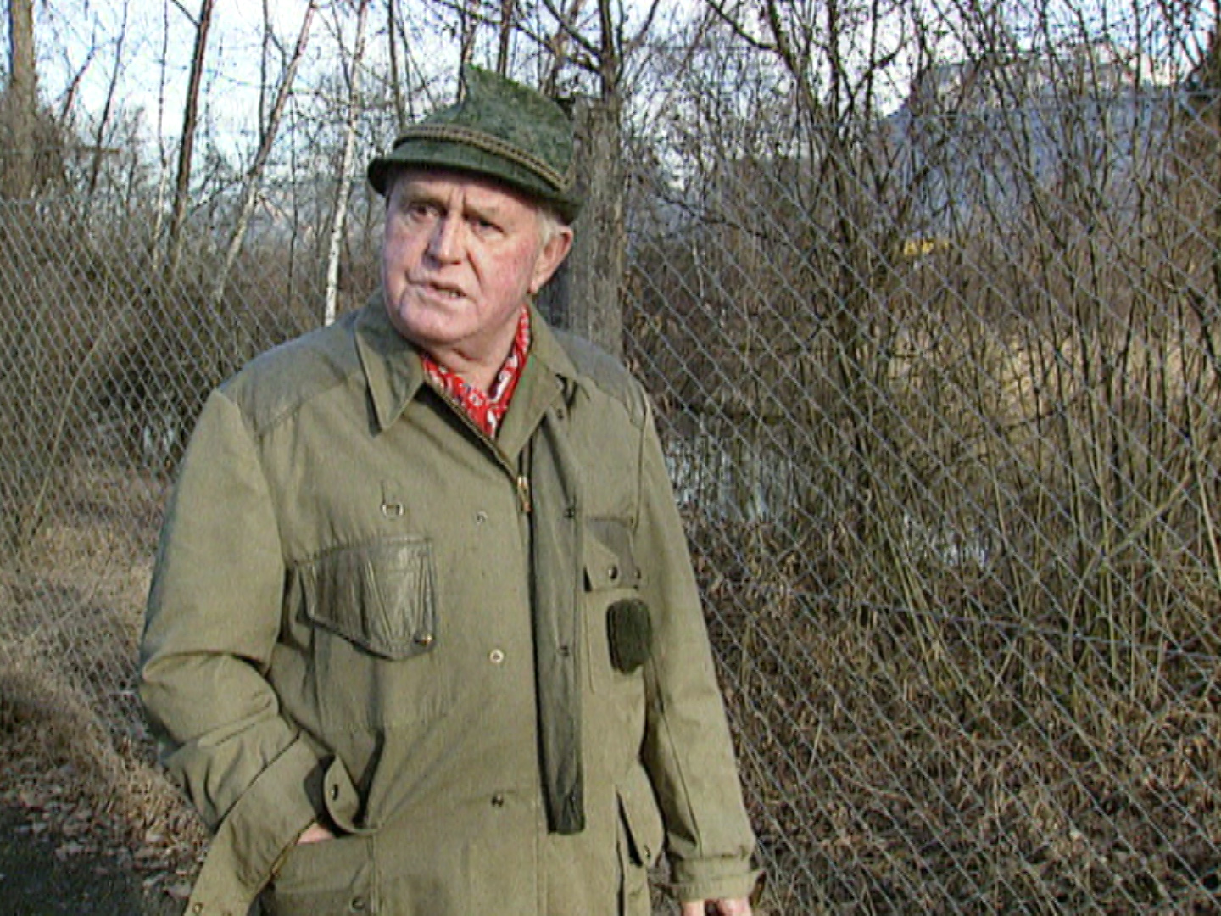
________________________________________________________________________________________________________________________________________________________________________________________________________________________________________________________________________________________________________________________________________________________________________________________________________________________________________________________________________________________________________________________________________________________________________________________________________________________________________________________________________________________________________________________________________________________________________________________________________________________________________________________________________________________________________________________________________________________________________________________________________________________________________________________________________________ | ________________________________________________________________________________________________________________________________________________________________________________________________________________________________________________________________________________________________________________________________________________________________________________________________________________________________________________________________________________________________________________________________________________________________________________  ________________________________________________________________________________________________________________________________________________________________________________________________________________________________________________________________________________________________________________________________________________________________________________________________________________________________________________________________________________________________

Jakob und Ida Kreutner  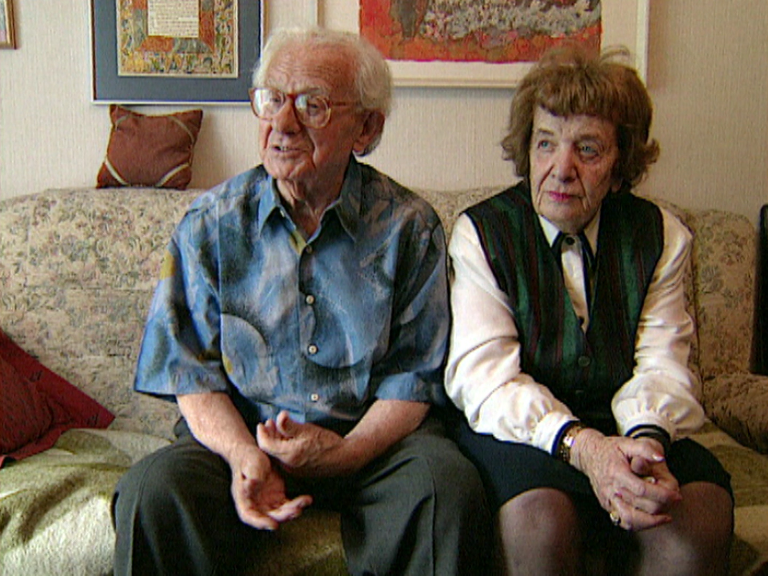 | Judith Kohn  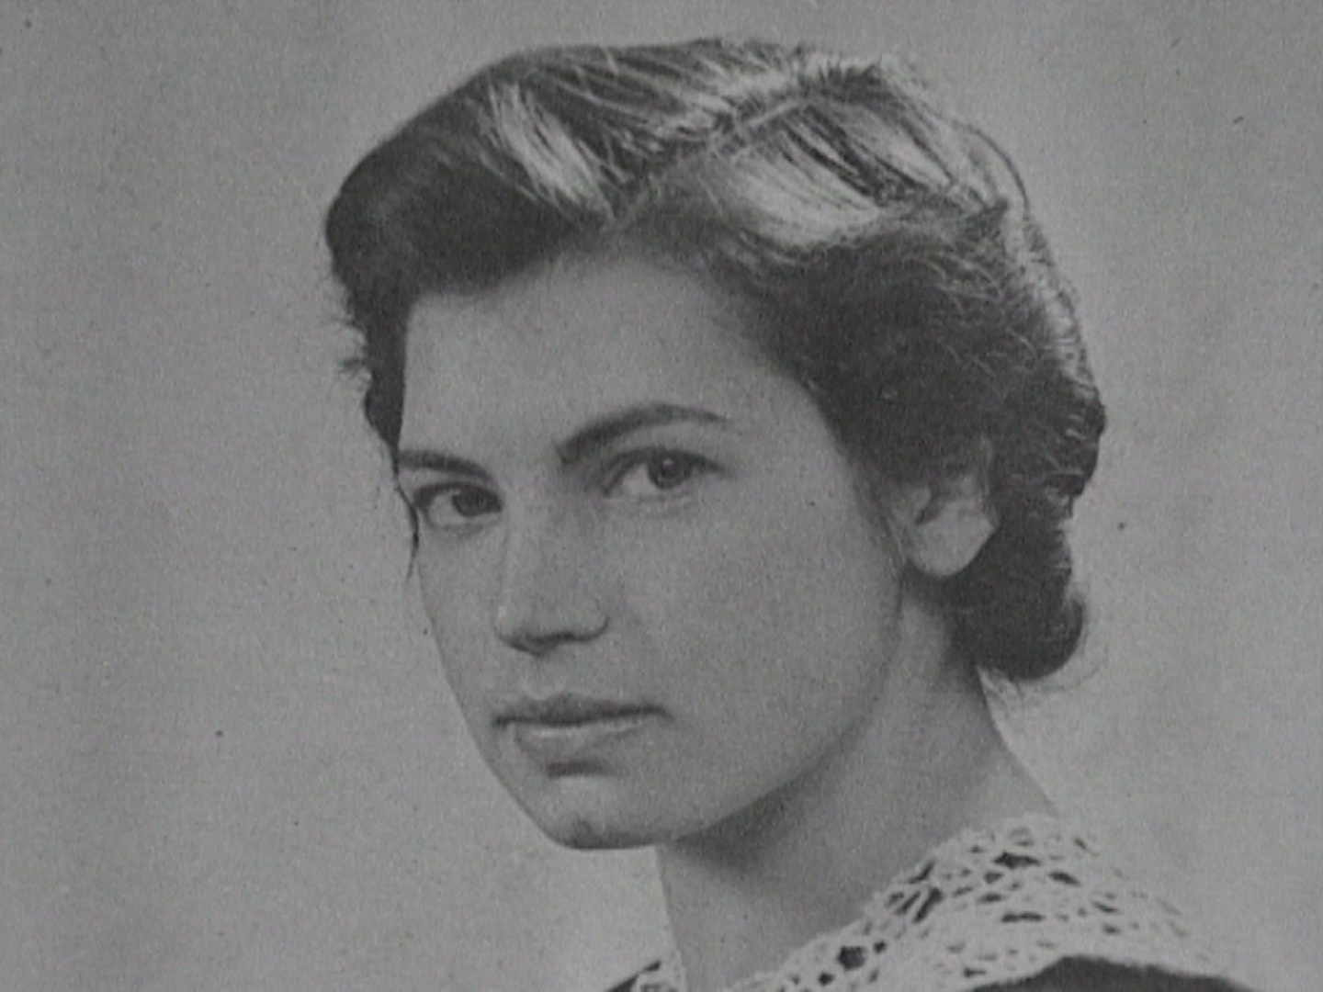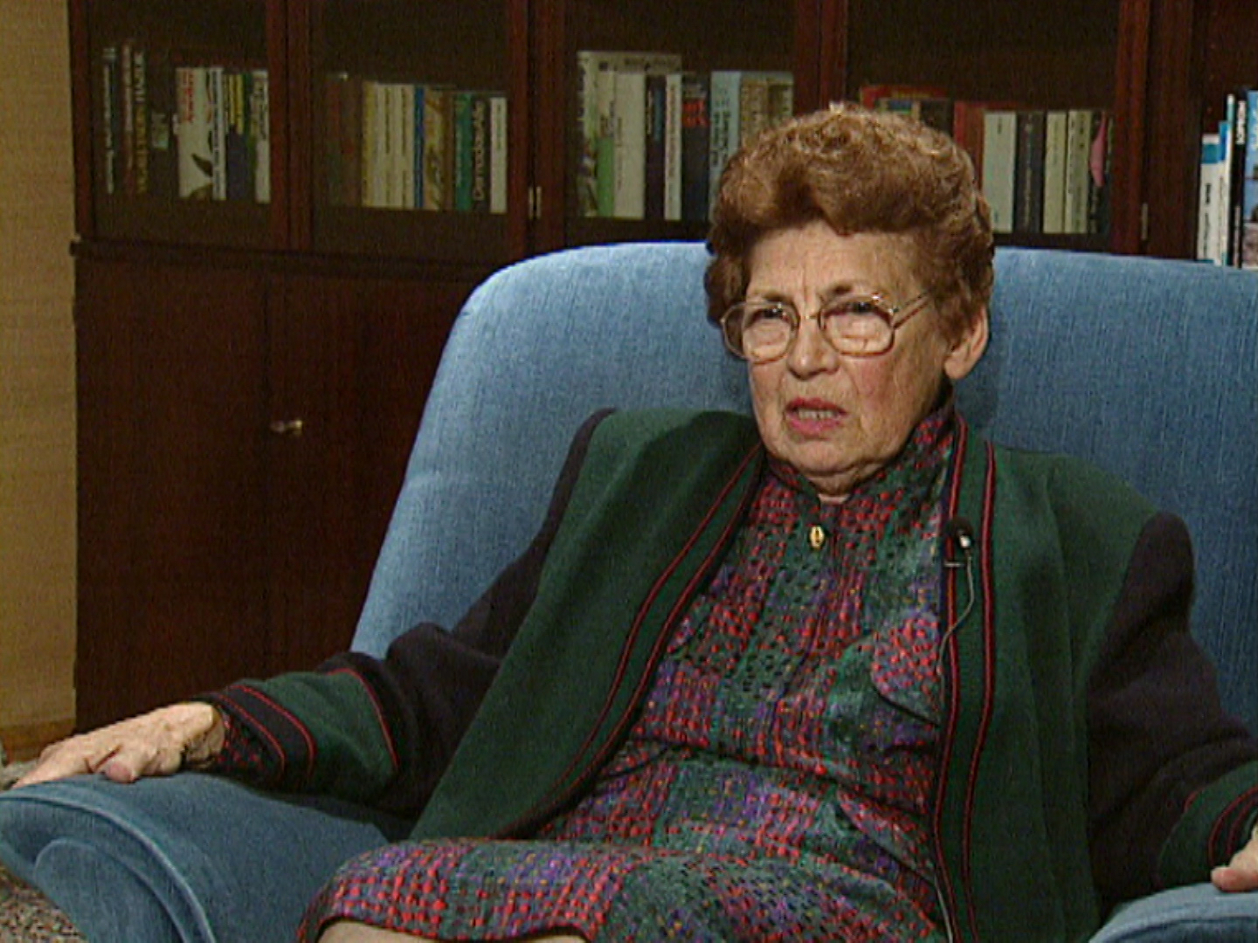
_______________________________________________________________________________________________________________________________________________________________________________________________________________________________________________________________________________________________________________________________________________________________________________________________________________________________________________________________________________________________________________________________________________________________________________________________________________________________________________________________________________________________________________________________________________________________________________________________________________________________________________________________________________________________________________________________________________________________________________________________________________________________________________________________________________________________________________________________________________________________ | ________________________________________________________________________________________________________________________________________________________________________________________________________________________________________________________________________________________________________________________________________________________________________________________________________________________________________________________________________________________________________________________________________________________________________________  ________________________________________________________________________________________________________________________________________________________________________________________________________________________________________________________________________________________________________________________________________________________________________________________________________________________________________________________________________________________________________________________________________________________________________________

Gertrud Kantorowicz  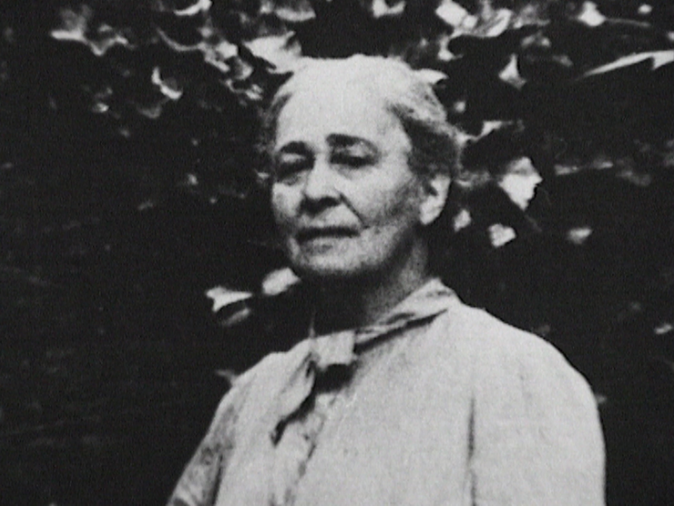 | Paul Grüninger  
    

